# **Motivations**

## **Non Linear Hypothesis**

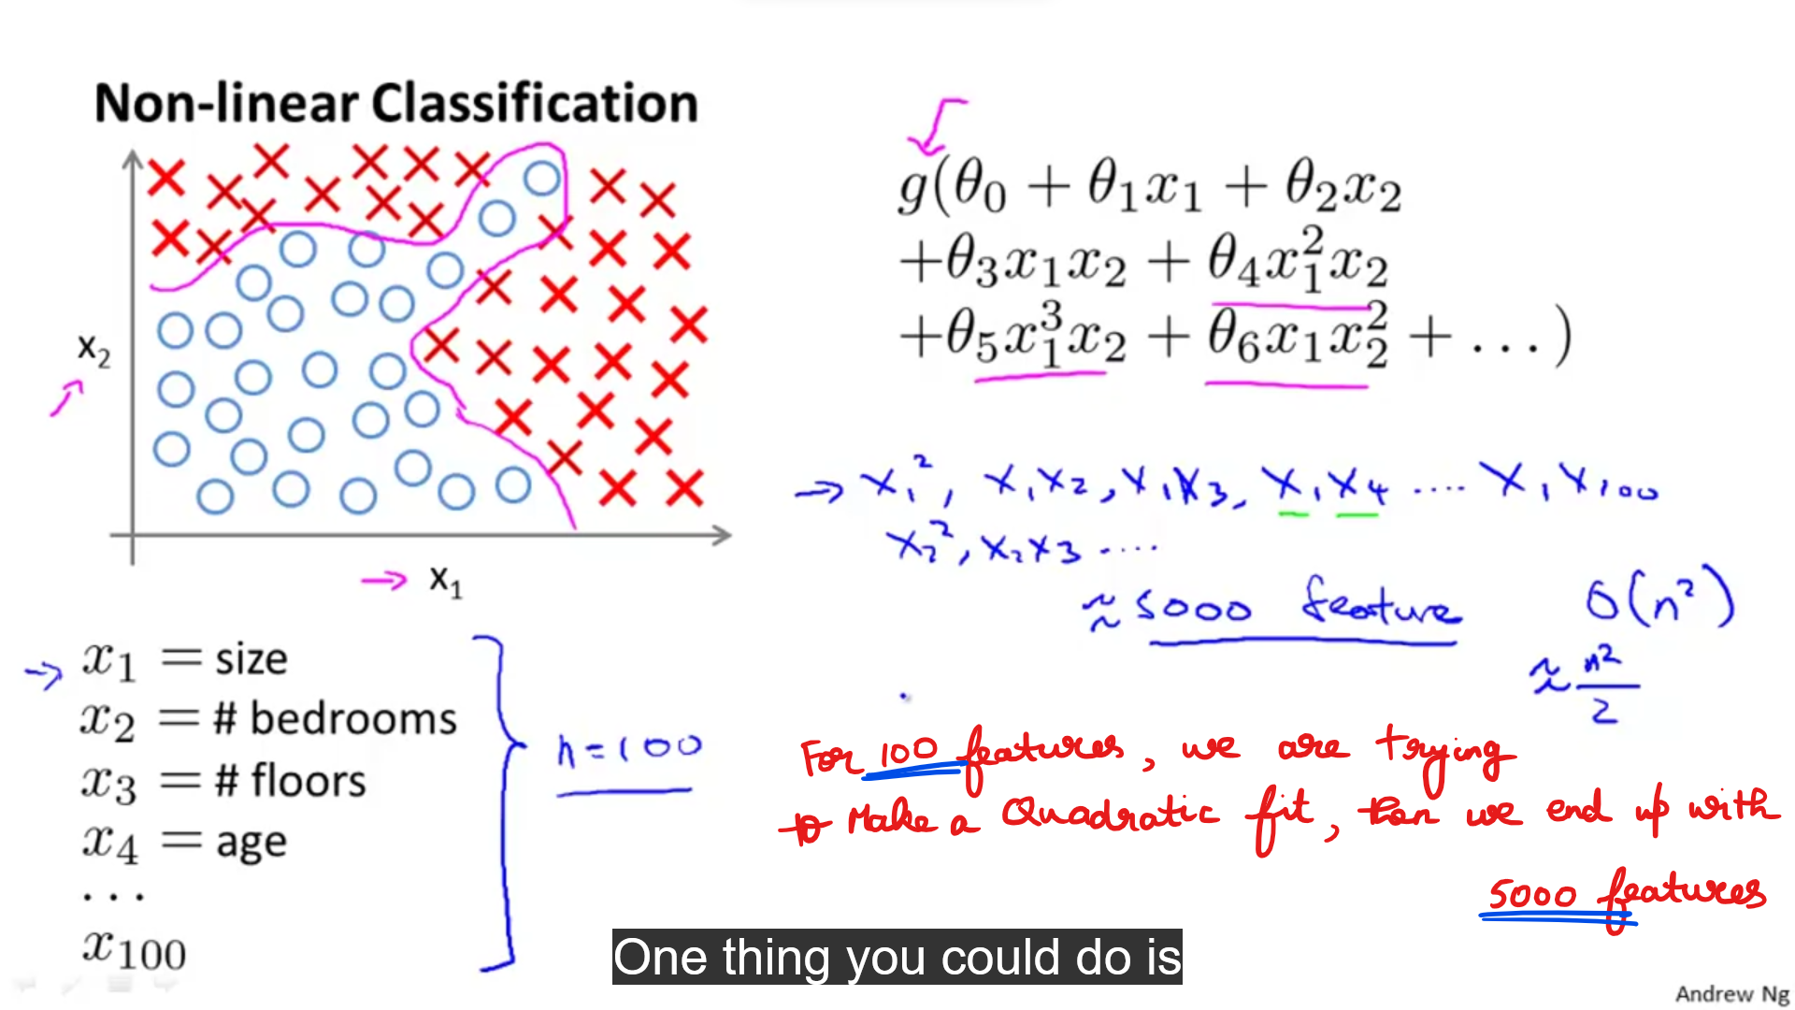  
The above features leads to over-fit the data.

* This is a super-vised Learning classification problem.
* Applying Logistic Regression to this problem.  
  By applying we got a hypothesis that separates positive and negative examples.
* This idea works well only for two features x1 and x2.

But in building a ML model, we require still more features to get better and accurate results.

There are 100 different features to predict the house price.  
So for this what will happen we include all the quadratic terms.

**Quadratic features**

Including all the quadratic features over-fits the data and computationally expensive.  
So we can include only a subset of features.

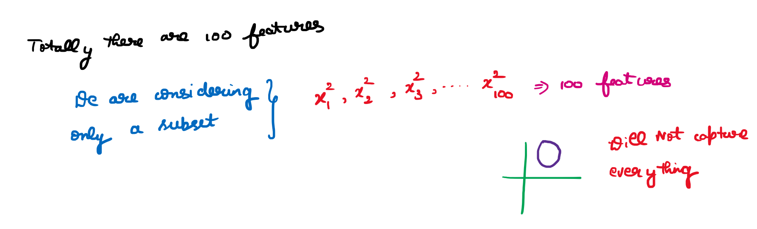Including only the above features doesn’t capture very complex hypothesis.  
It will result in a circle which is totally in-evident.

**Cubic features**

Consider this problem of Computer Vision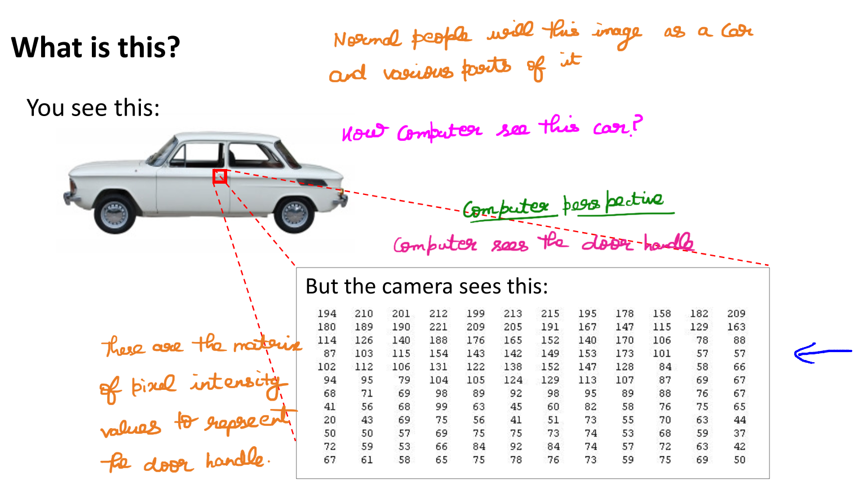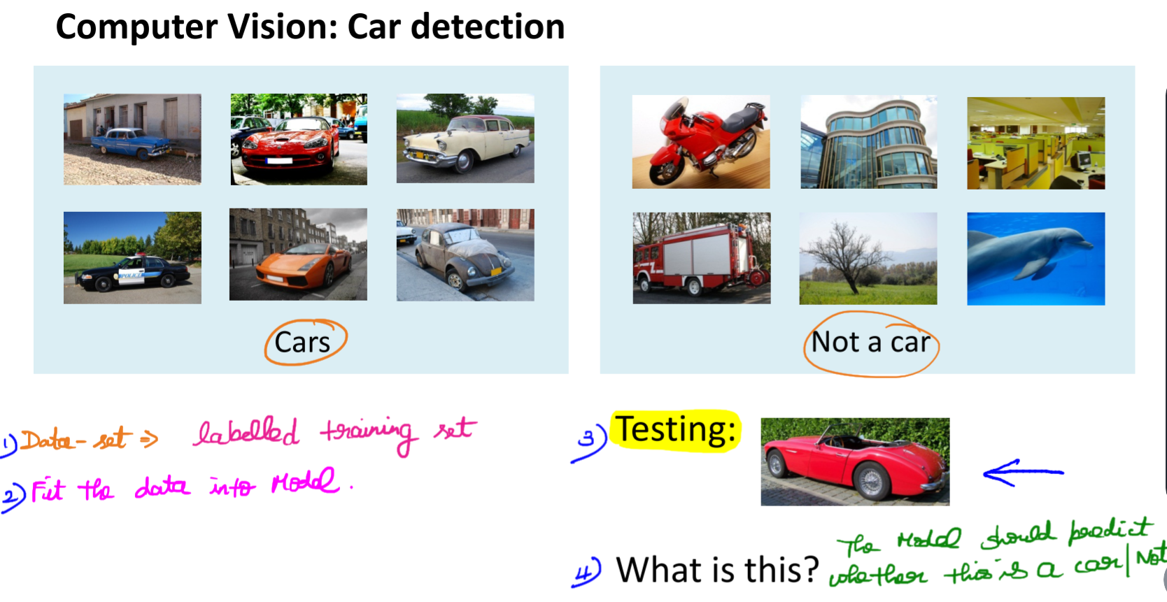

Need for a Non-Linear Hypothesis

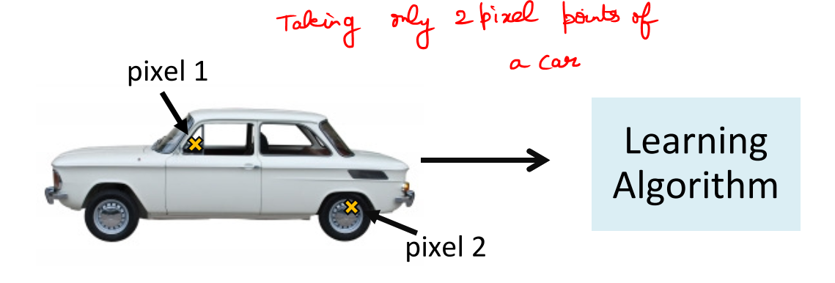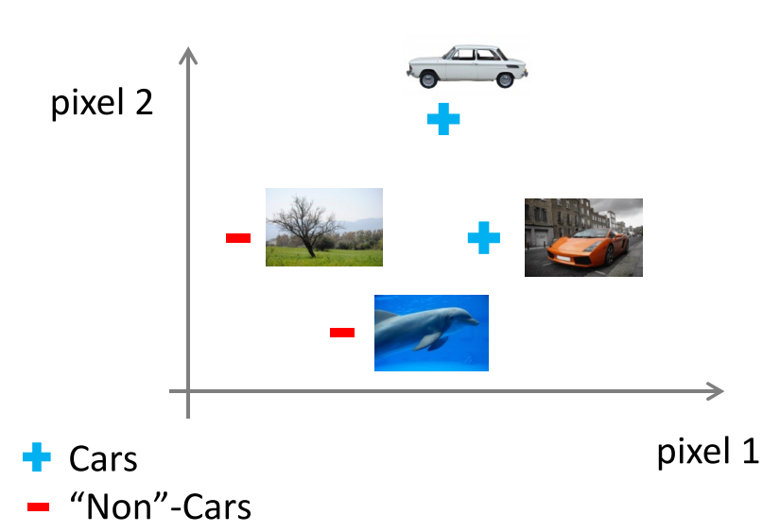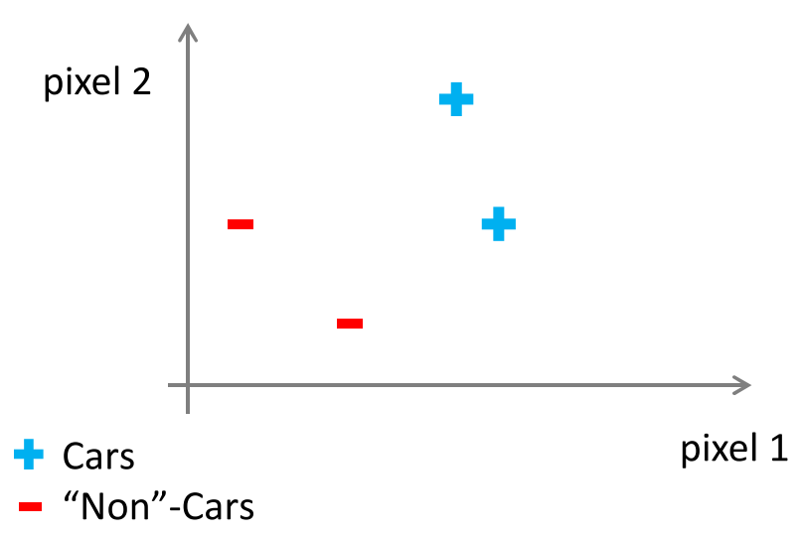

Lets put all the pixel values and their corresponding type (i.e cars/non cars)

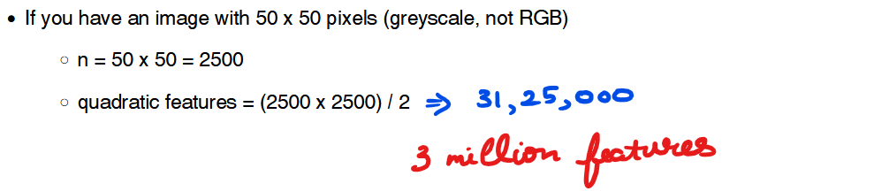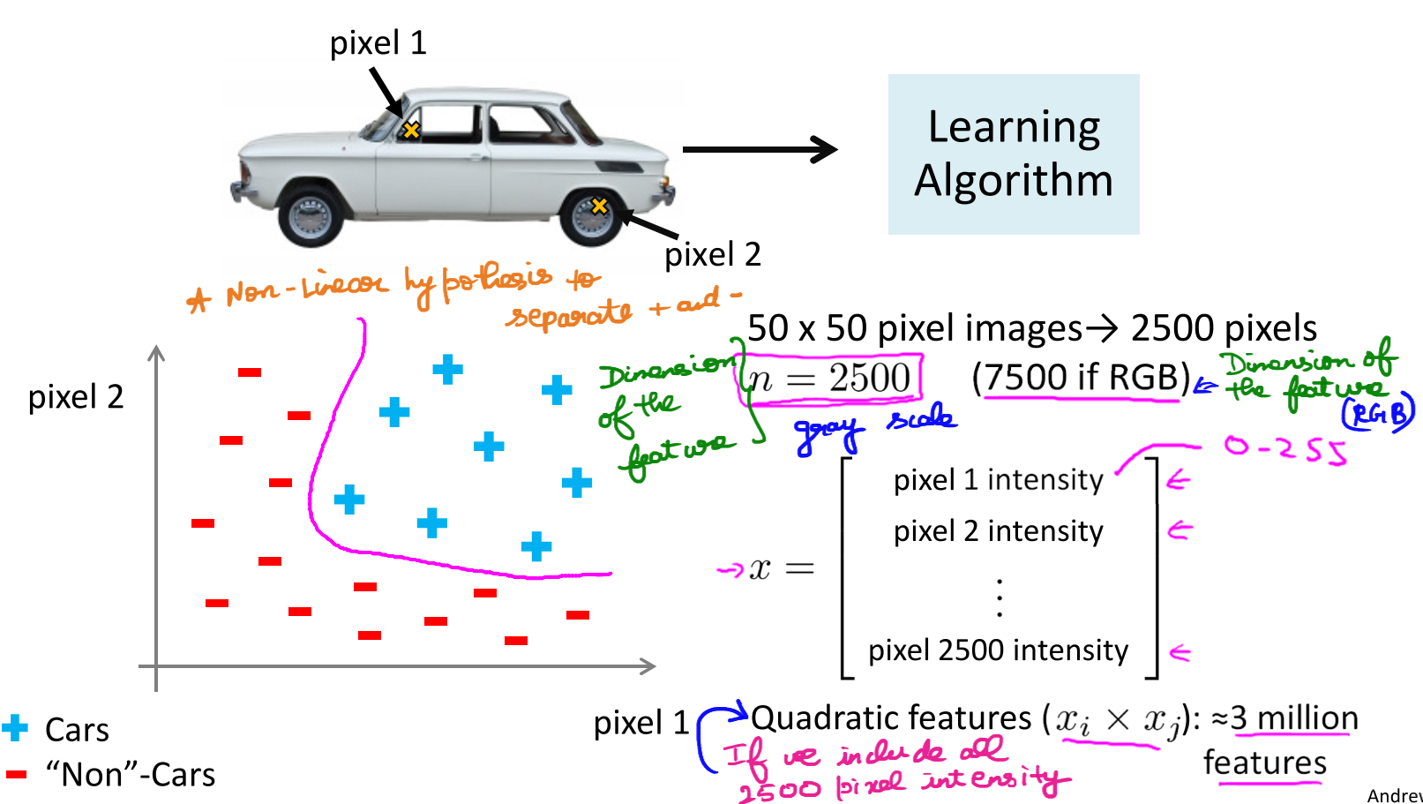

## **Quiz**

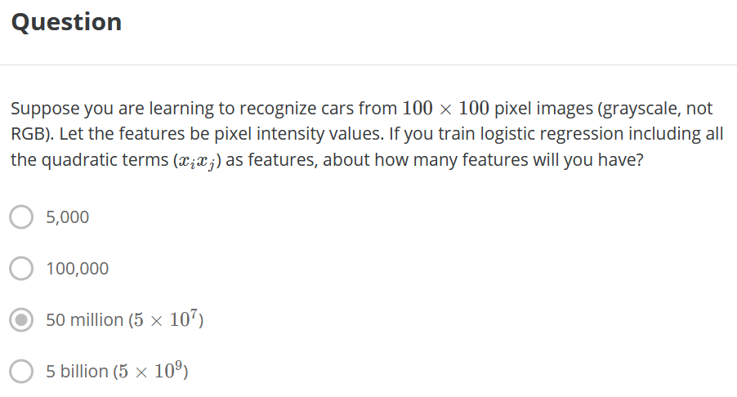  


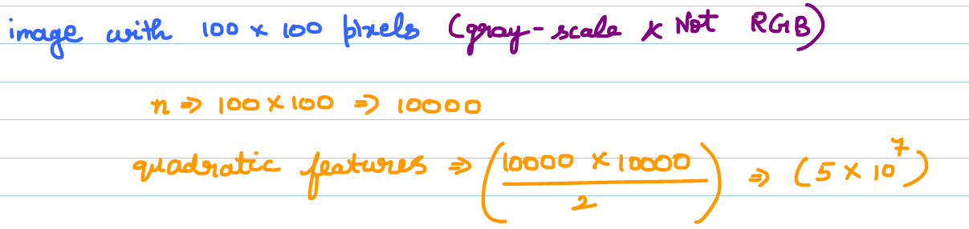

So, simple logistic regression together with adding in maybe the quadratic or the cubic features - that's just not a good way to learn complex nonlinear hypotheses when n is large because you just end up with too many features.

## **Neurons and the Brain**

### **Neuro Re-wiring Experiments**

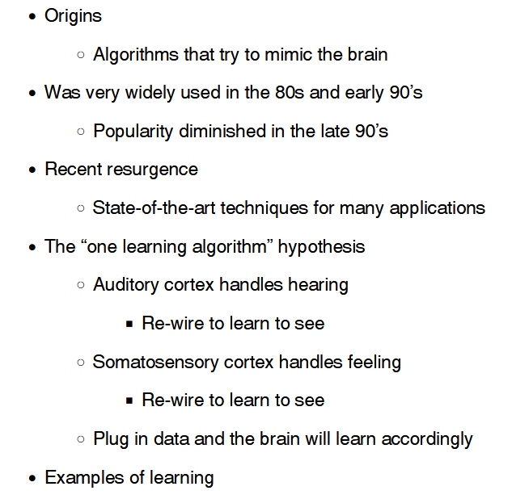

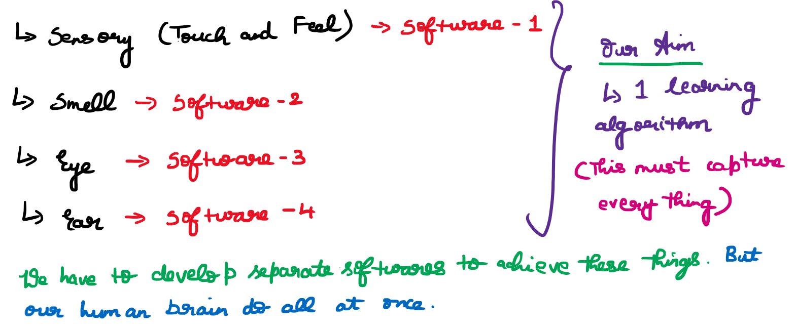

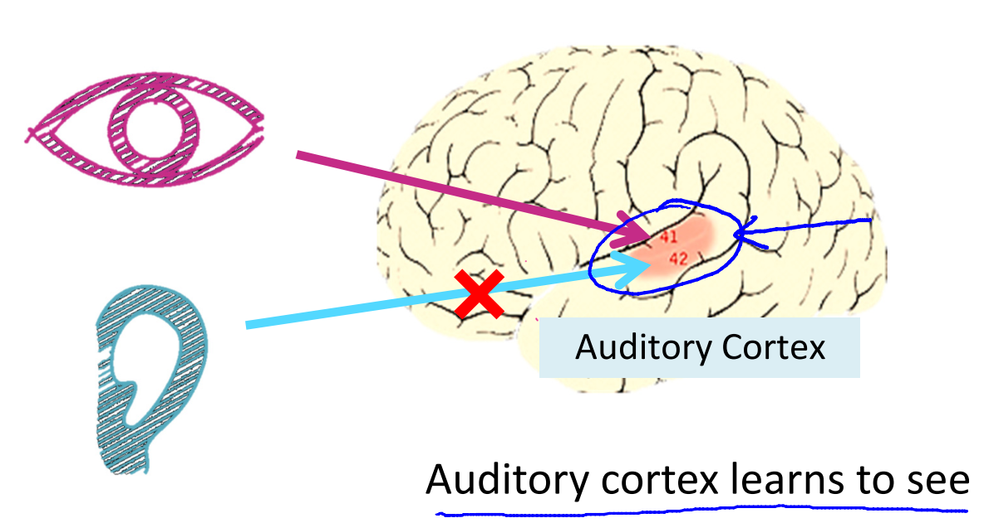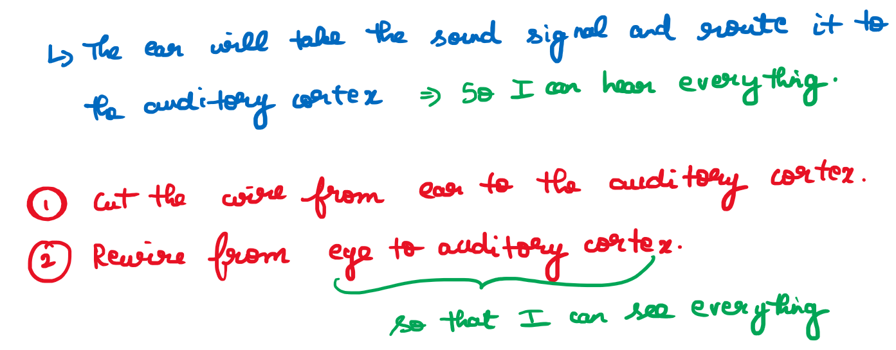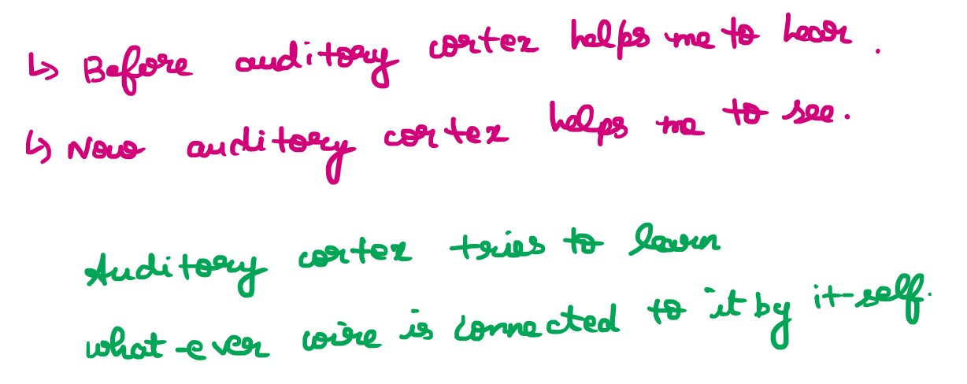

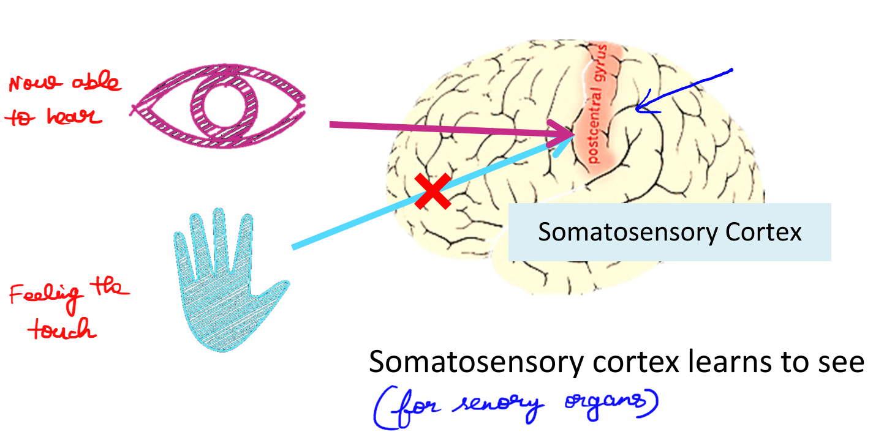

And instead of needing to implement a thousand different programs or a thousand different algorithms to do, you know, the thousand wonderful things that the brain does, maybe what we need to do is figure out some approximation or to whatever the brain's learning algorithm is and implement that and that the brain learned by itself how to process these different types of data.

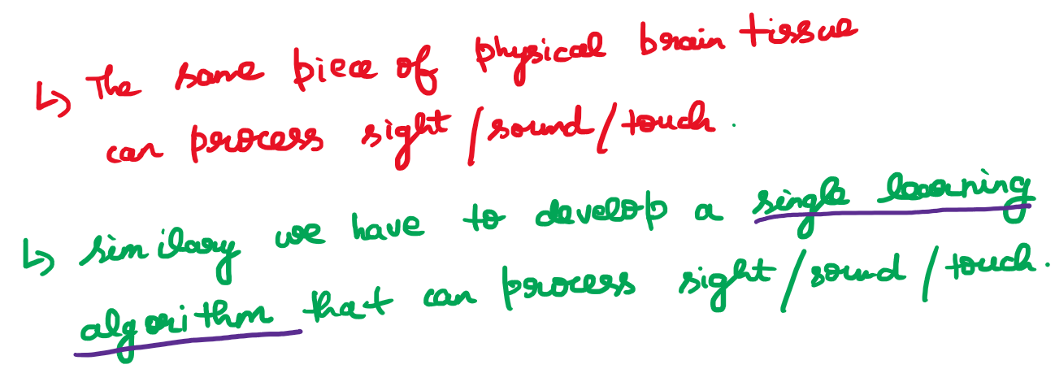

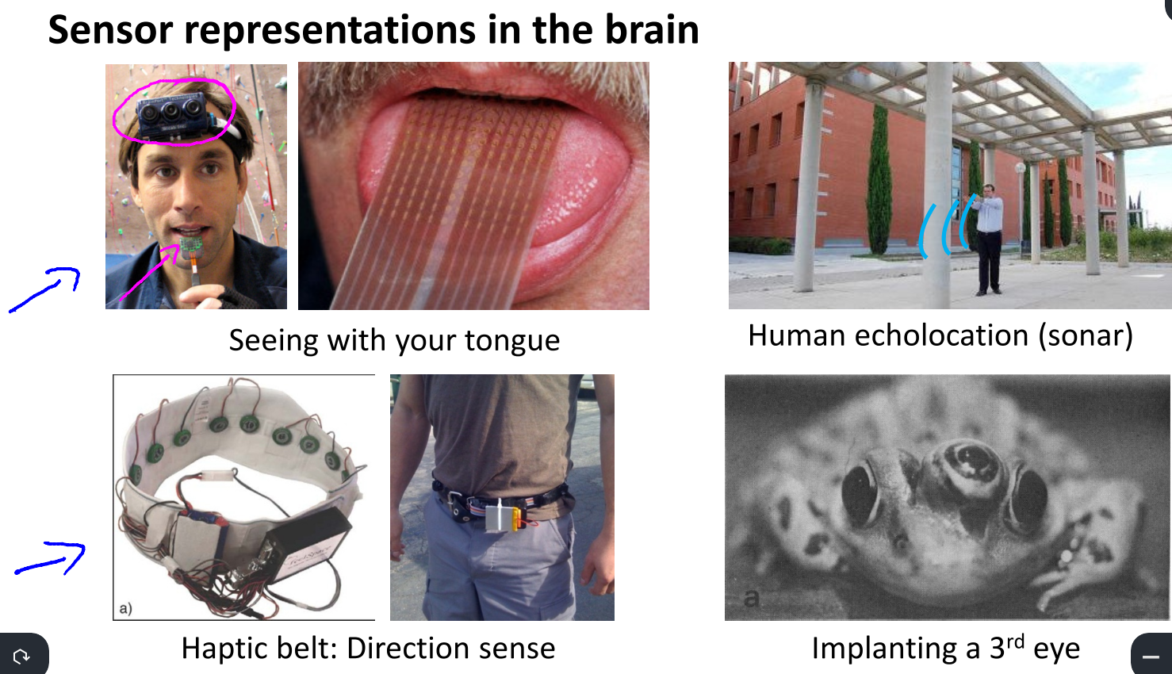

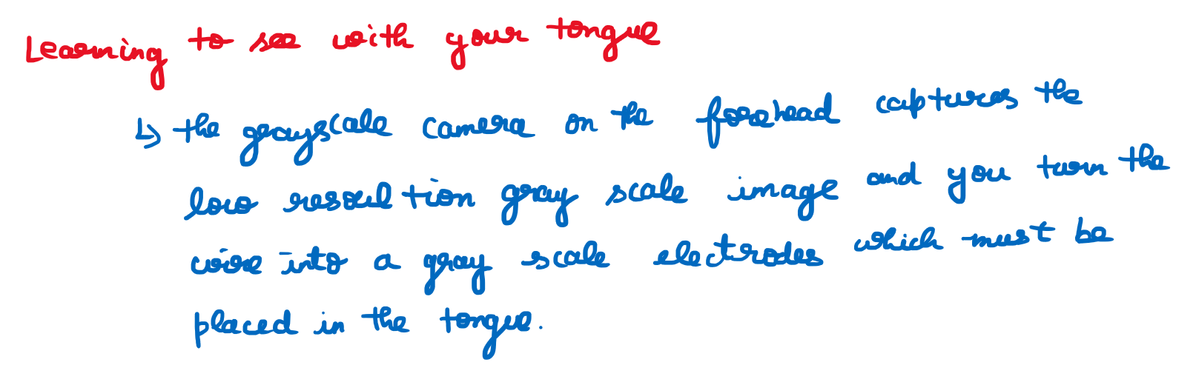

So that each pixel gets mapped to a location on your tongue where maybe a high voltage corresponds to a dark pixel and a low voltage corresponds to a bright pixel and, even as it does today, with this sort of system you and I will be able to learn to see, you know, in tens of minutes with our tongues.

  
The blind people can clap their hands, so that the sound reaches and bounce back from the objects that is in front of them. In this way they will able to identify which is object is in front of them.



Third example is the Haptic Belt where if you have a strap around your waist, ring up buzzers and always have the northmost one buzzing. You can give a human a direction sense similar to maybe how birds can, you know, sense where north is. it's pretty amazing to what extent is as if you can plug in almost any sensor to the brain and the brain's learning algorithm will just figure out how to learn from that data and deal with that data.

***it's pretty amazing to what extent is as if you can plug in almost any sensor to the brain and the brain's learning algorithm will just figure out how to learn from that data and deal with that data.***

And there's a sense that if we can figure out what the brain's learning algorithm is, and, you know, implement it or implement some approximation to that algorithm on a computer, maybe that would be our best shot.

# **Neural Networks**

## **Model Representation-1**

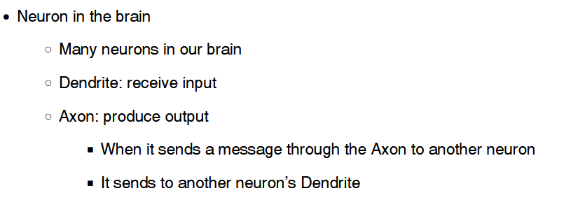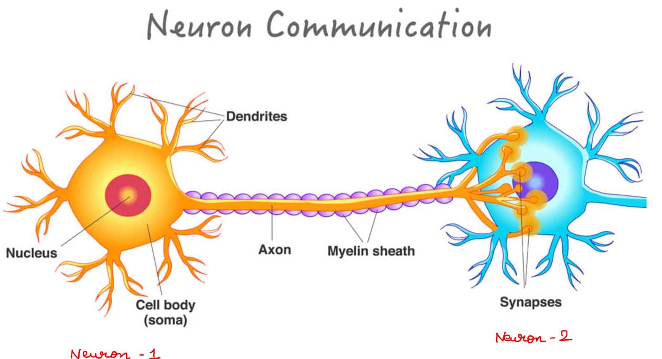

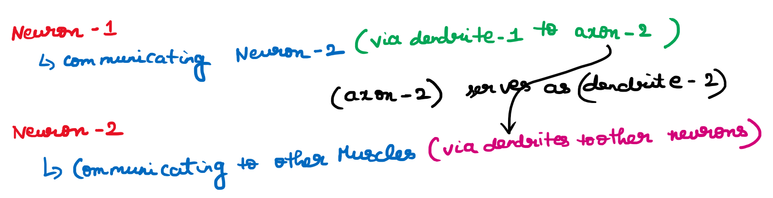

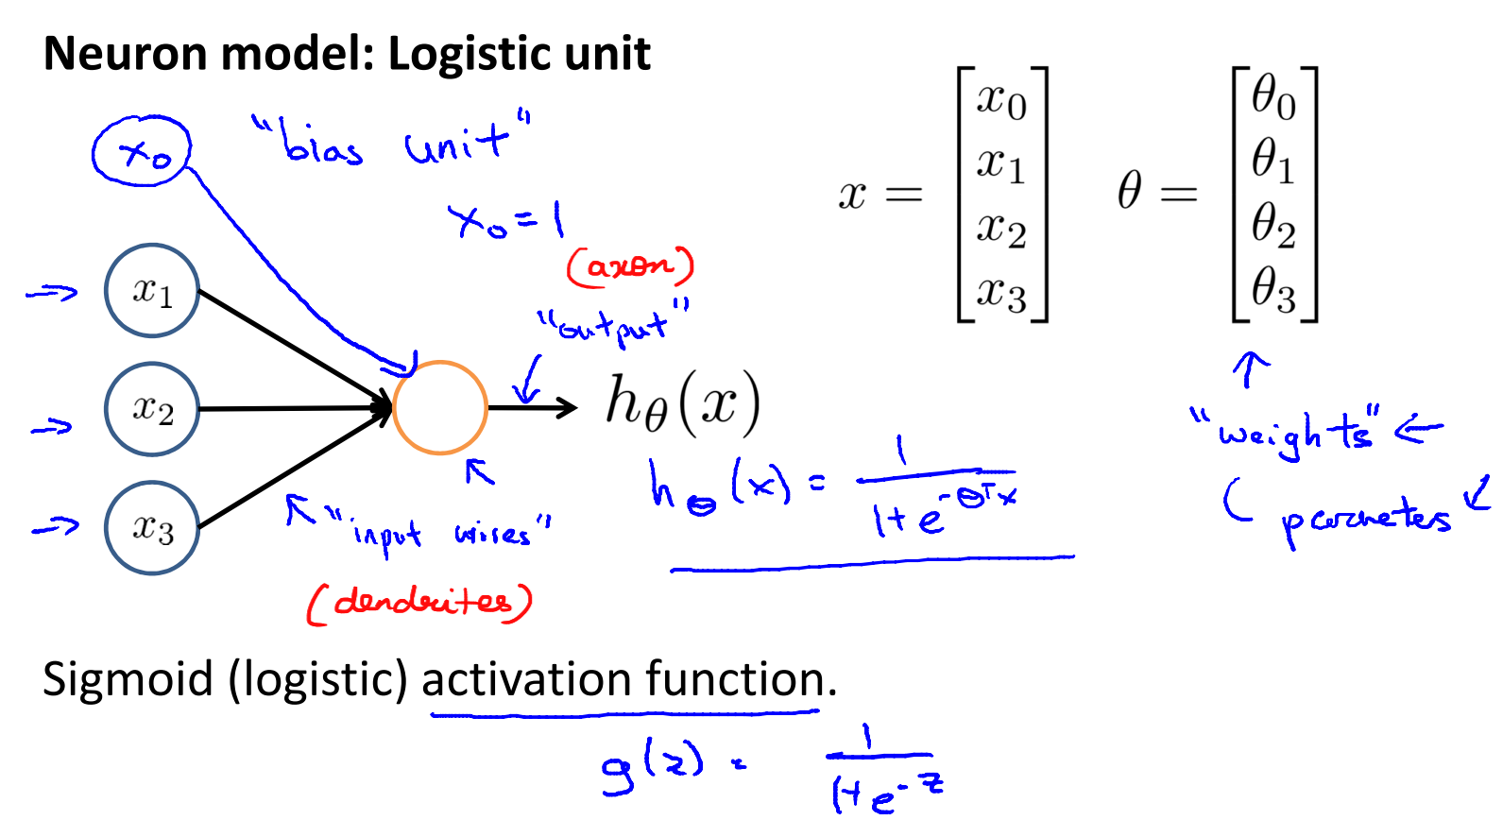

The above diagram represents a single neuron.  
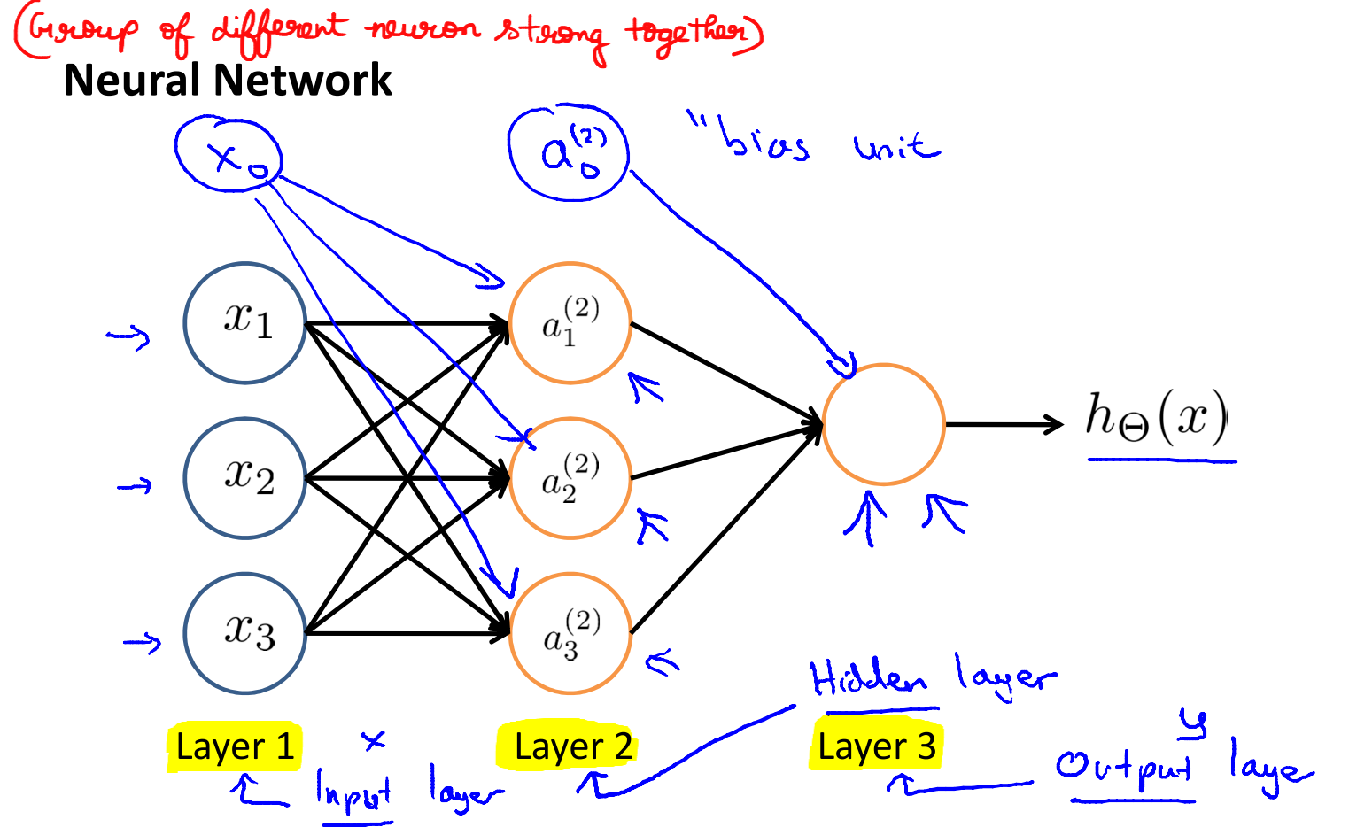

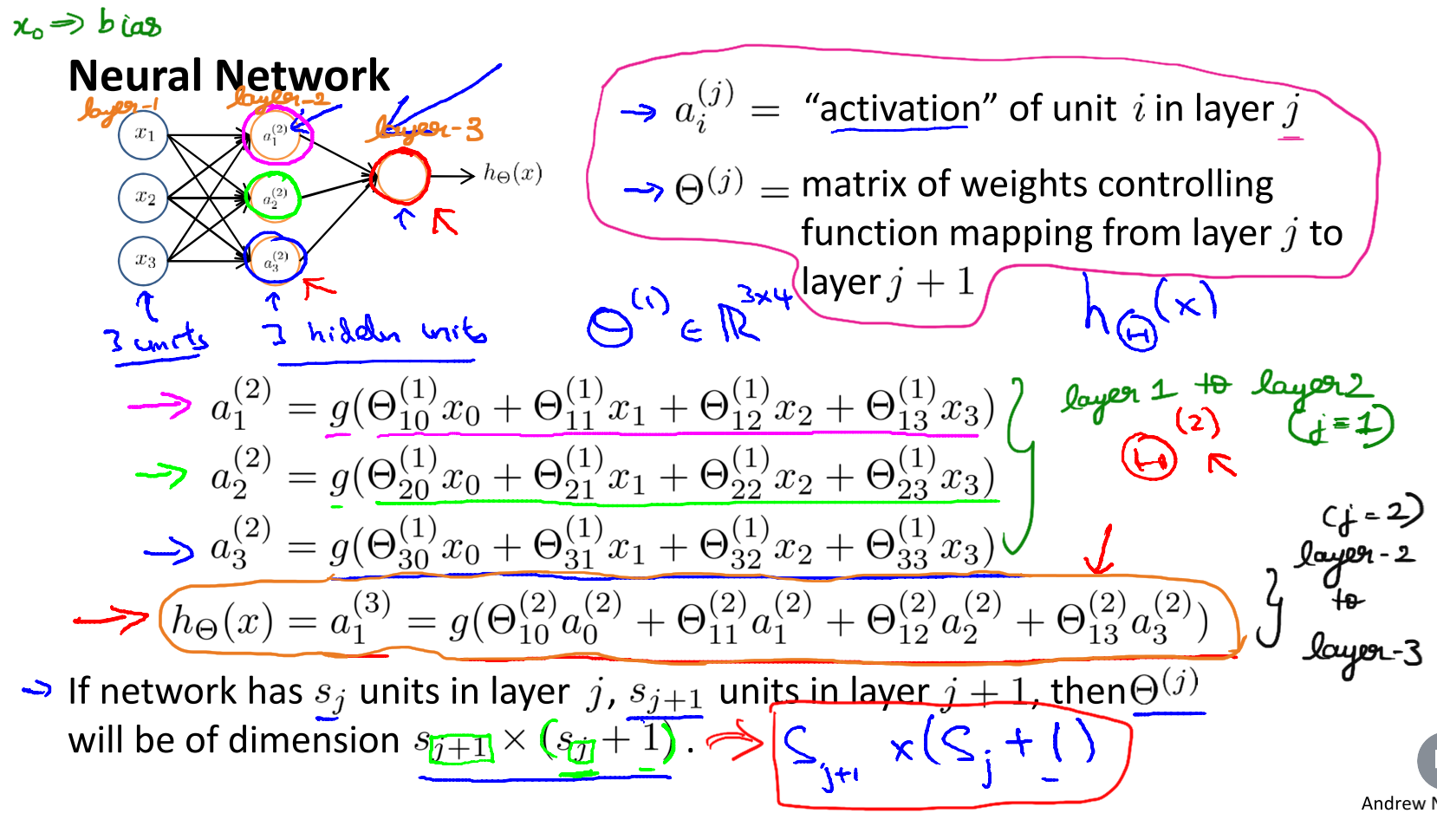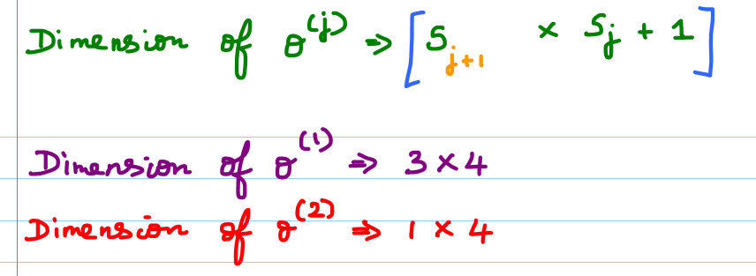

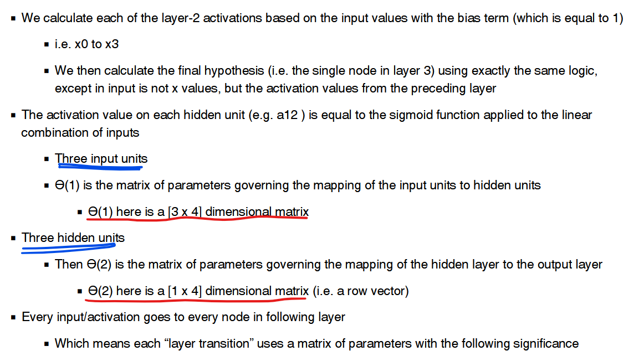

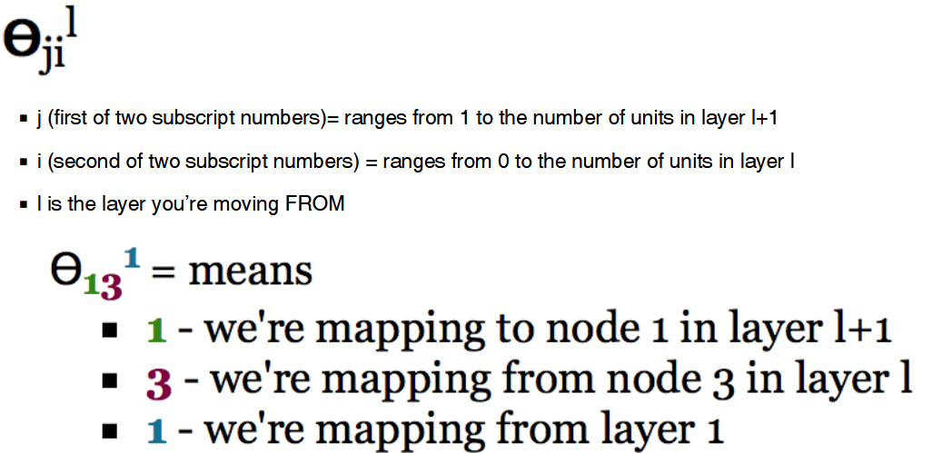

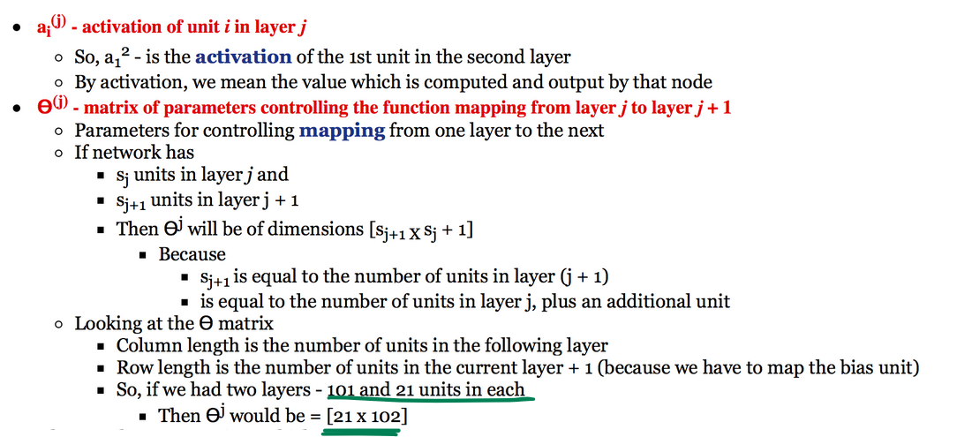

### **Quiz**

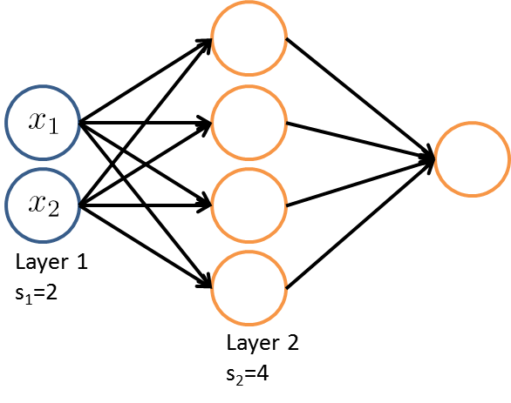

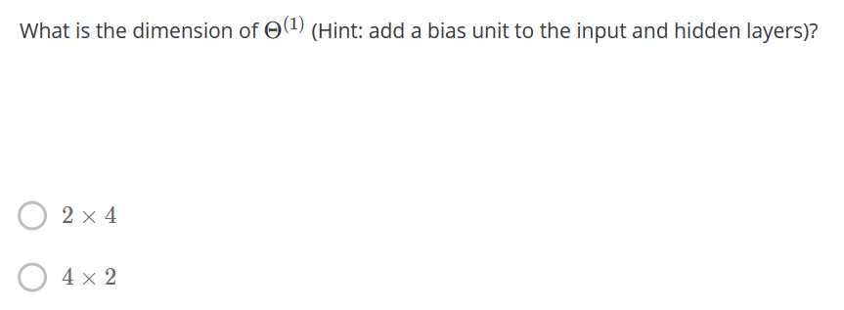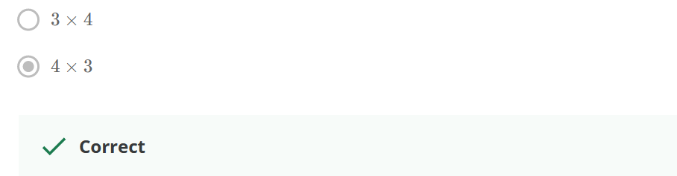

### **Reading-Model Representation-1**

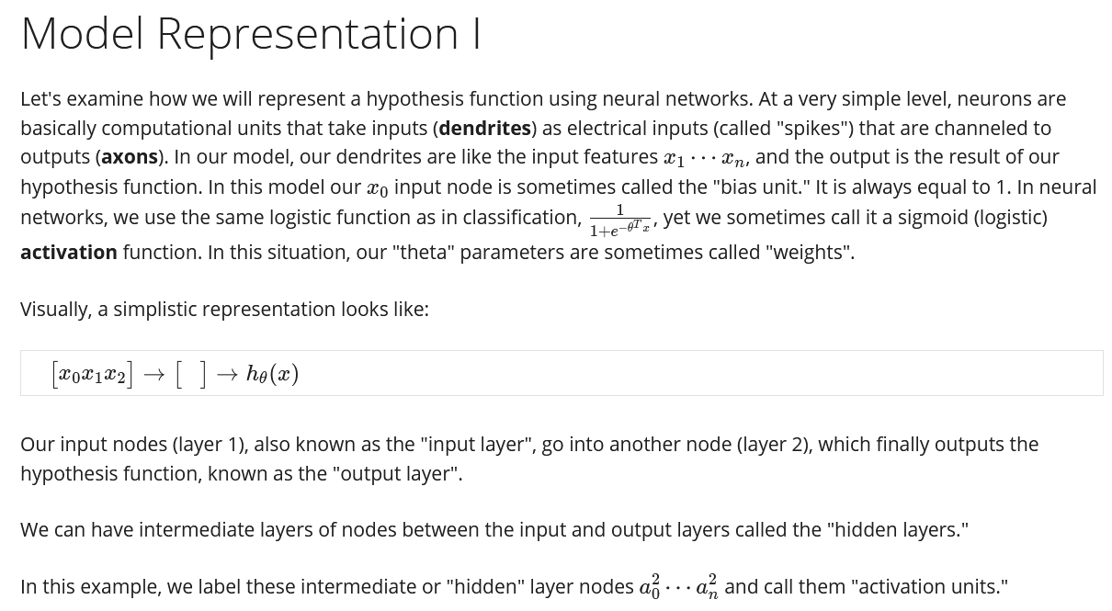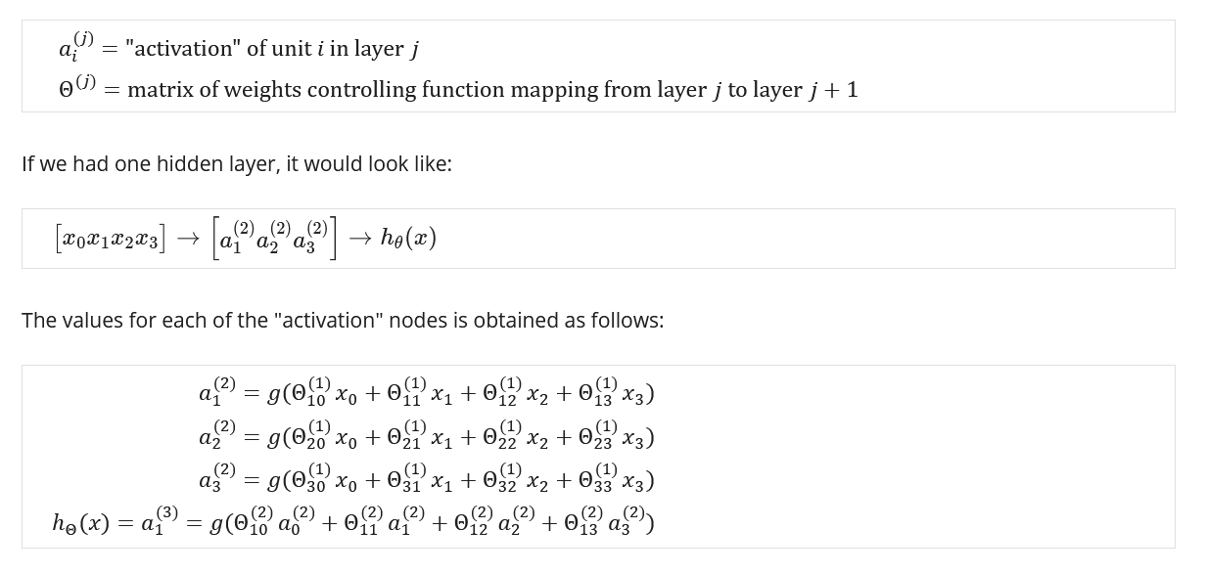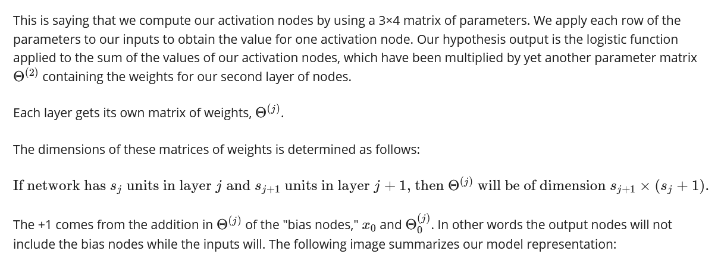

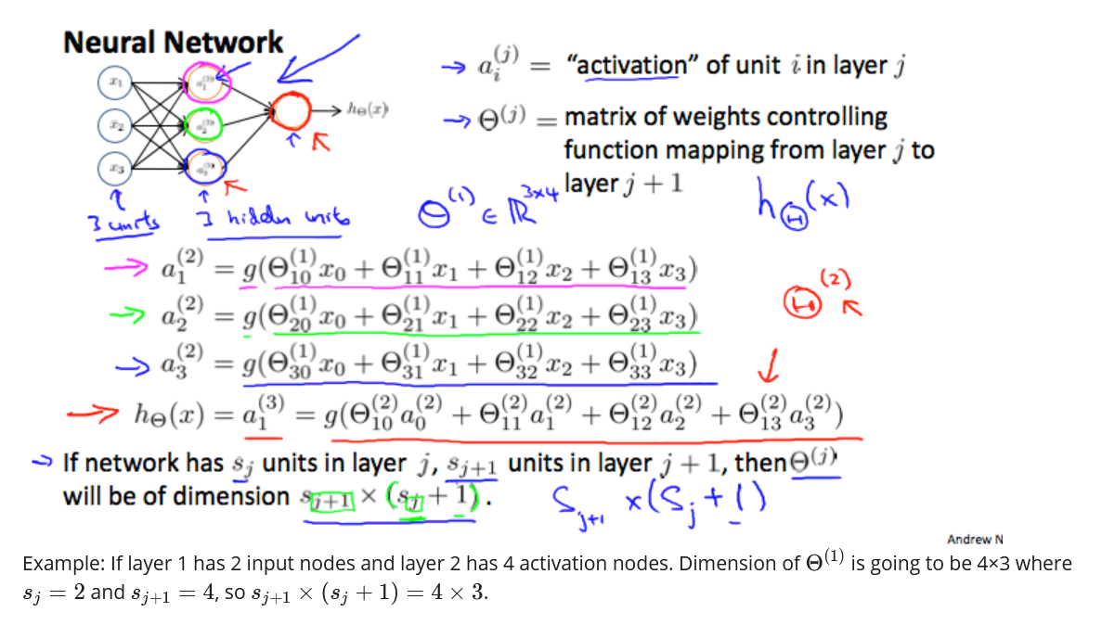

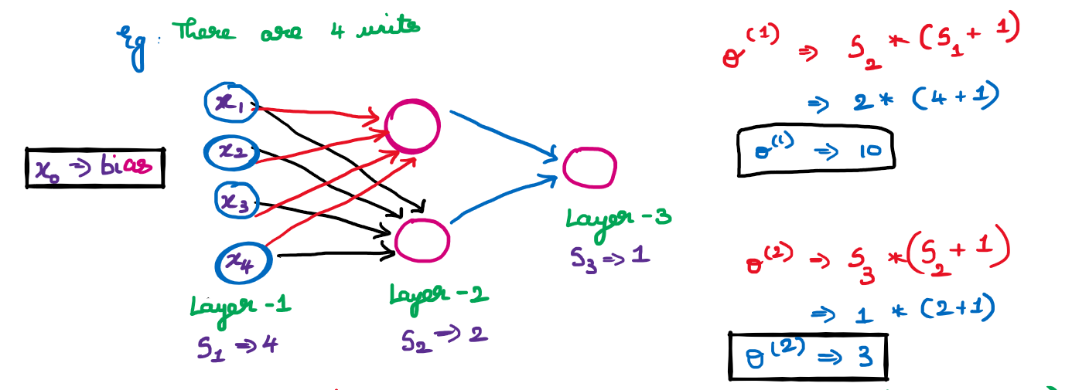  
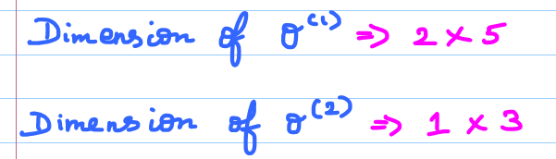

## **Model Representation-2**

### **Forward Propagation : Vectorized Implementation**

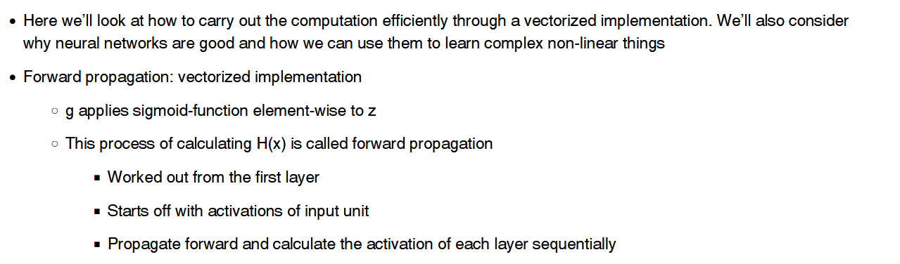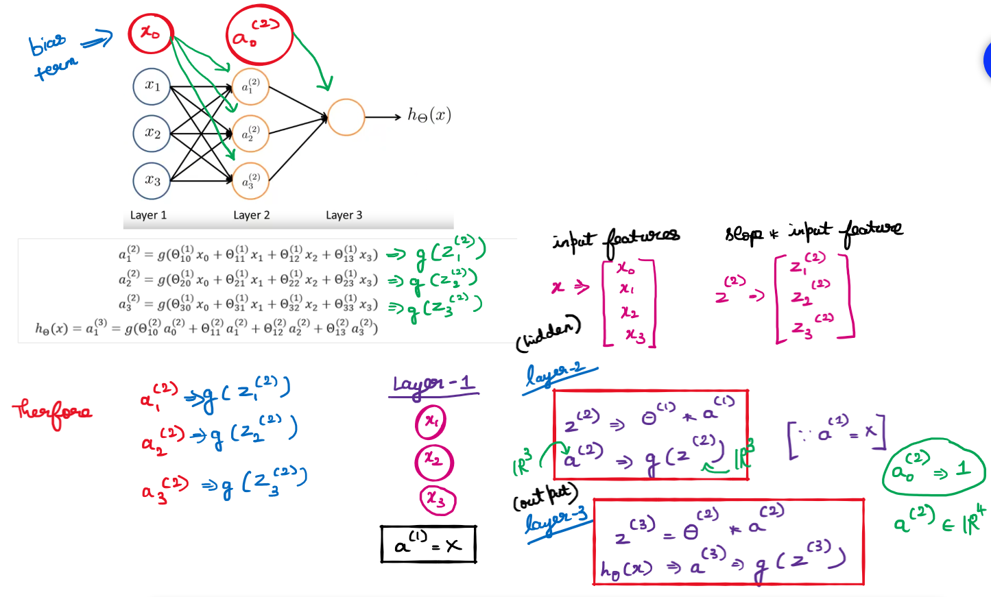

### **Neural Network Learning its own Features**

This forward propagation view also helps us to understand what Neural Networks might be doing and why they might help us to learn interesting nonlinear hypotheses.

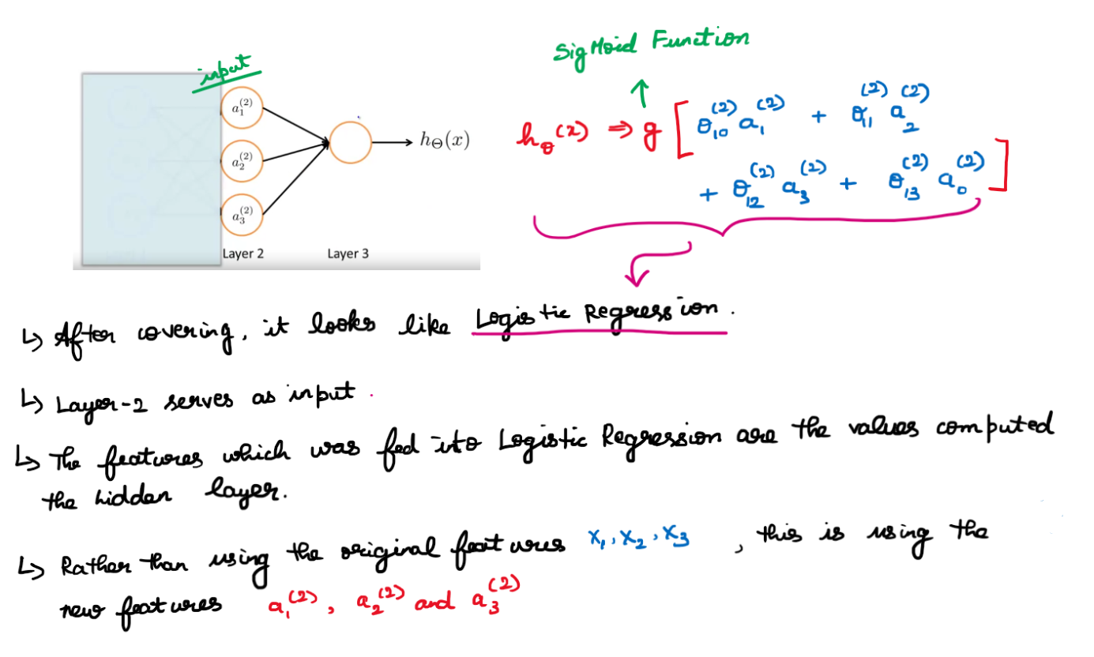

* And the cool thing about this, is that the features a1, a2, a3, they themselves are learned as functions of the input.
* Concretely, the function mapping from layer-1 to layer-2, that is determined by some other set of parameters, theta 1.
* So it's as if the neural network, instead of being constrained to feed the features x1, x2, x3 to logistic regression.
* It gets to learn its own features, a1, a2, a3, to feed into the logistic regression and as you can imagine depending on what parameters it chooses for theta 1.
* You can learn some pretty interesting and complex features and therefore you can end up with a better hypotheses than if you were constrained to use the raw features x1, x2 or x3 or if you will constrain to say choose the polynomial terms, you know, x1, x2, x3, and so on.
* But instead, this algorithm has the flexibility to try to learn whatever features at once, using these a1, a2, a3 in-order to feed into this last unit that's essentially a logistic regression here.

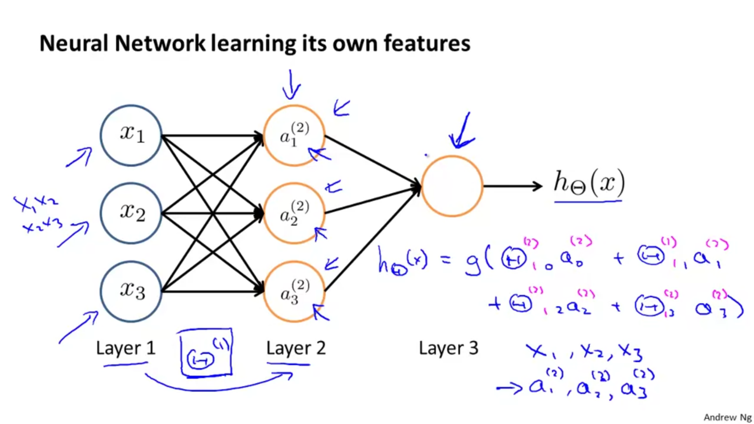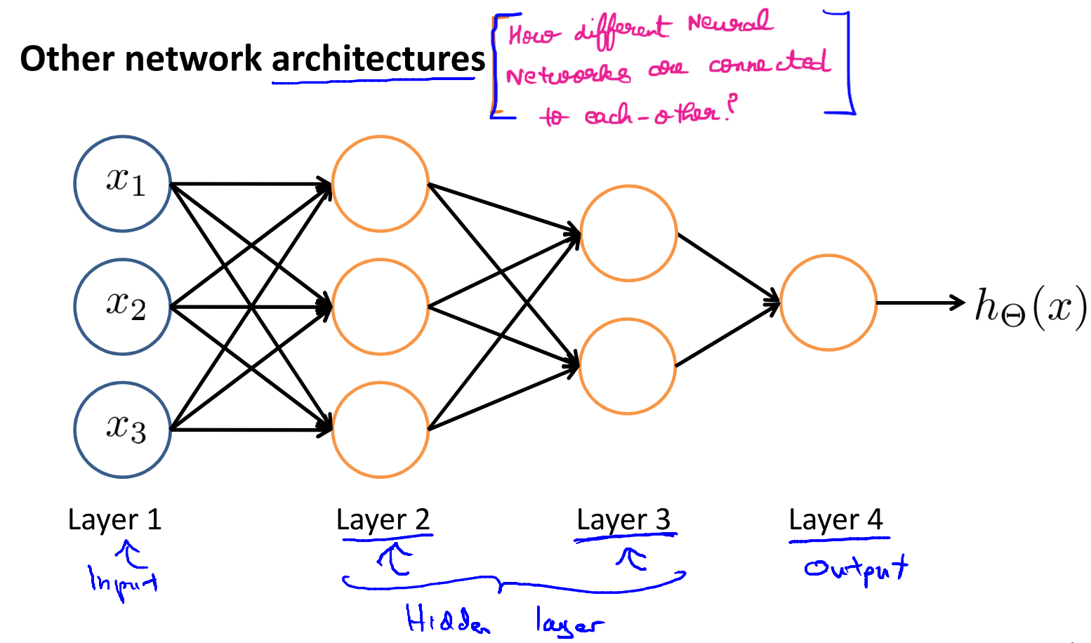

### **Quiz**

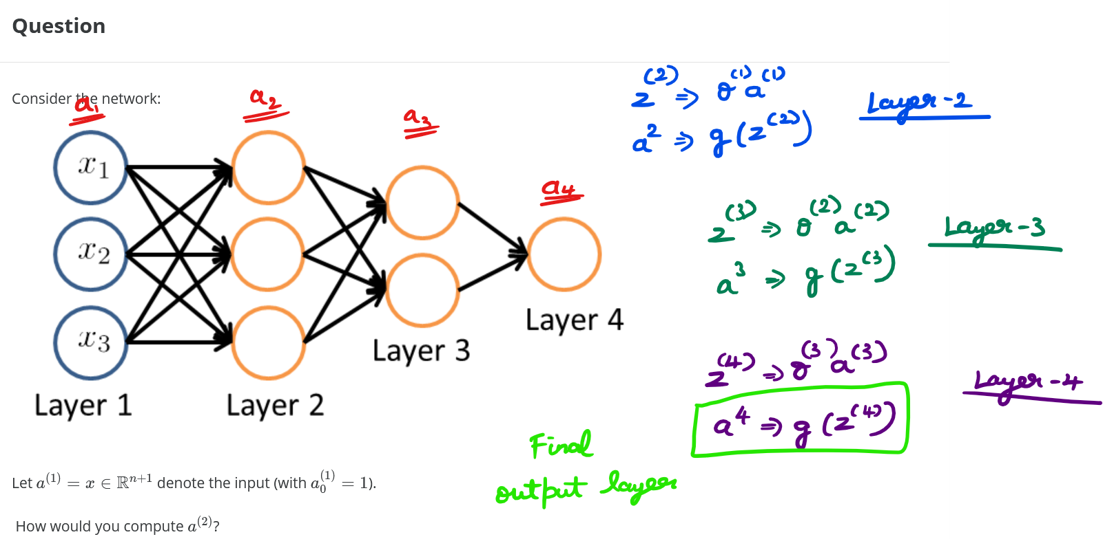  
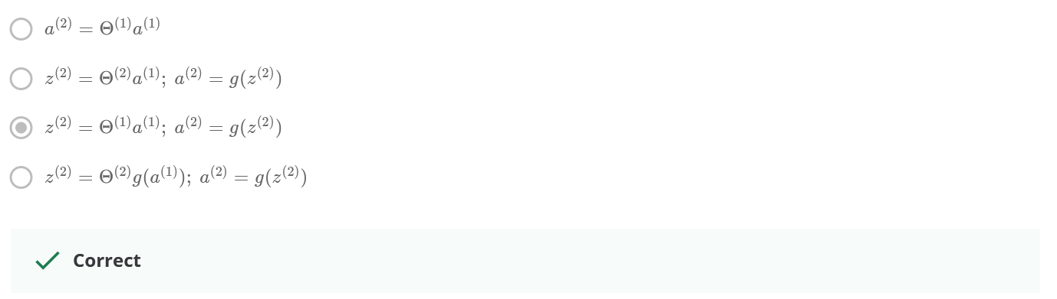

### **Reading – Model Representation-2**

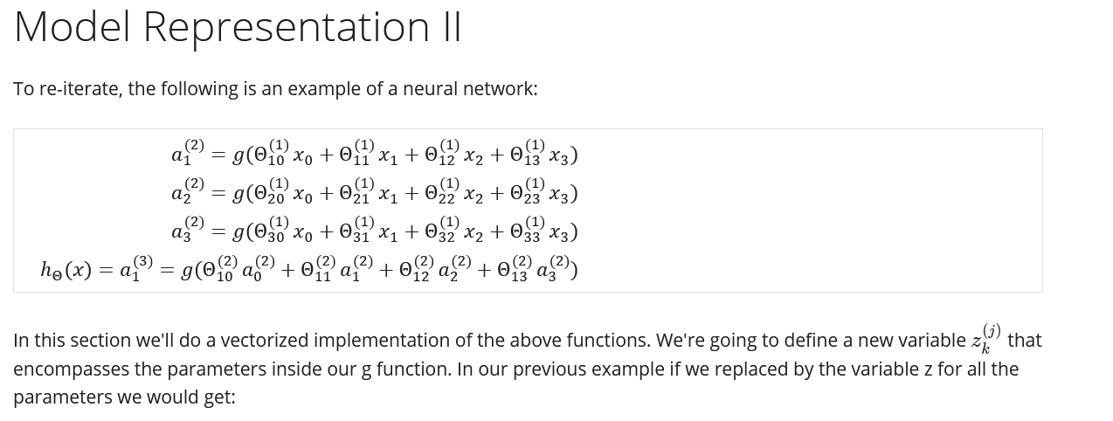  
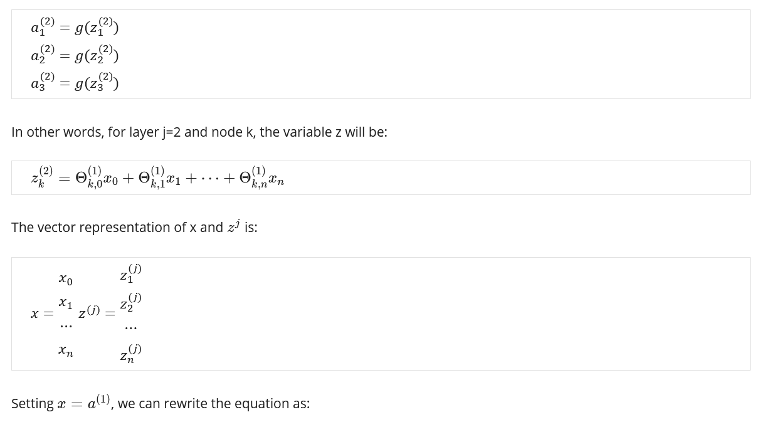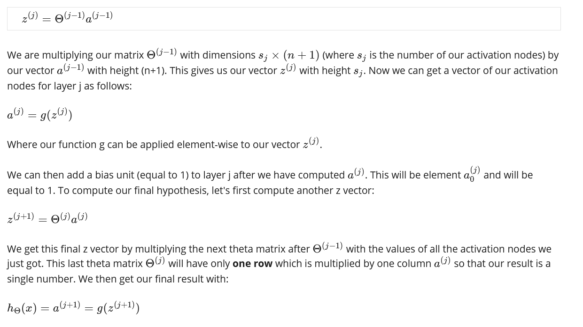

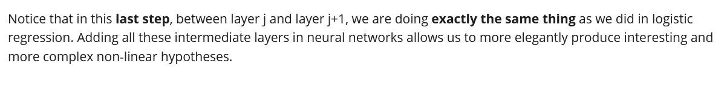

# **Applications**

### **Quiz**

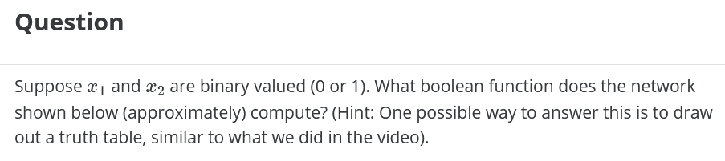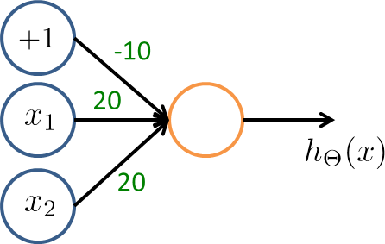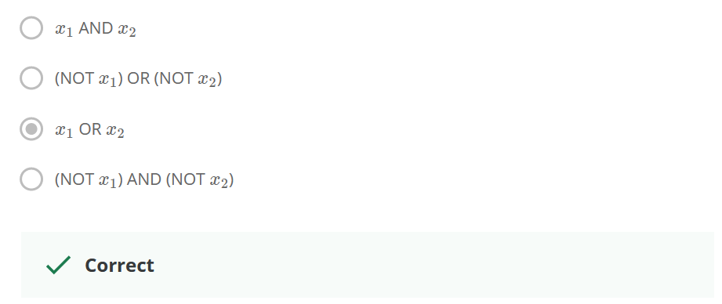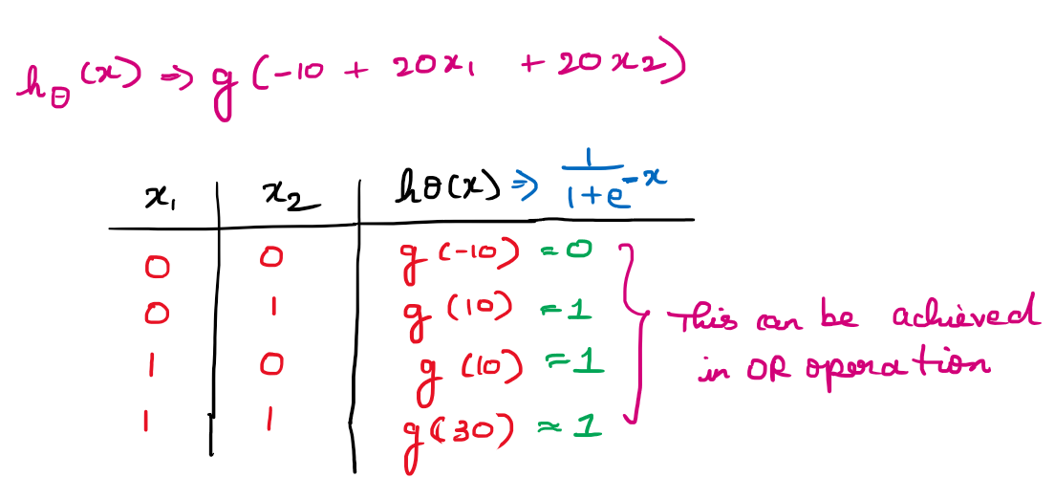

### **Reading Examples and Intuition-1**

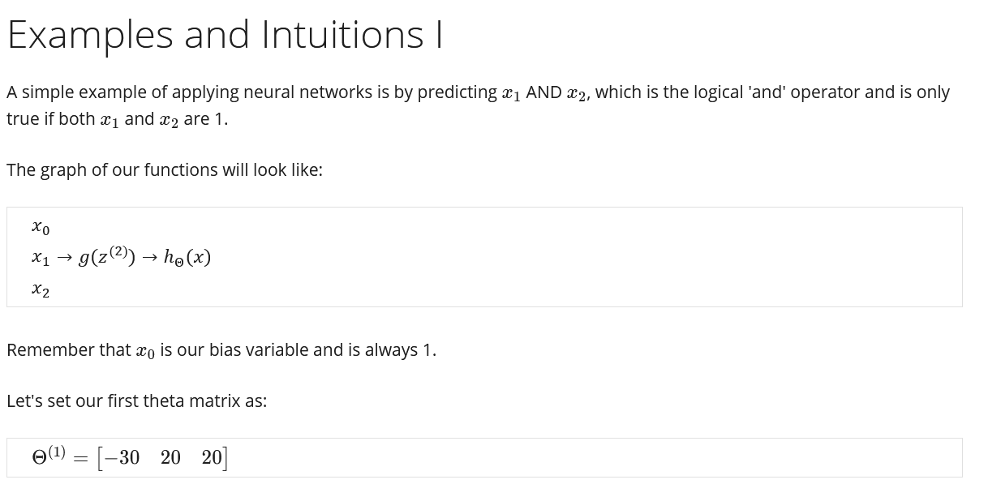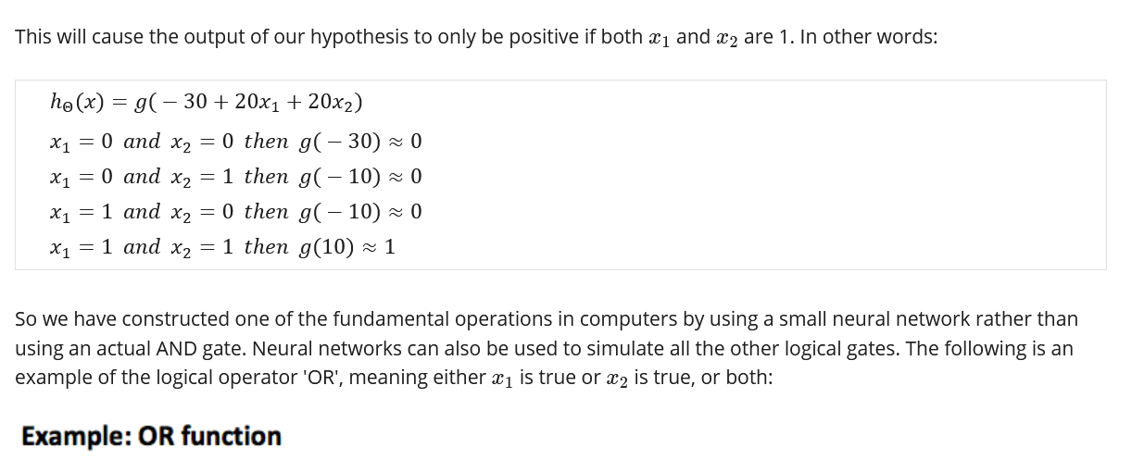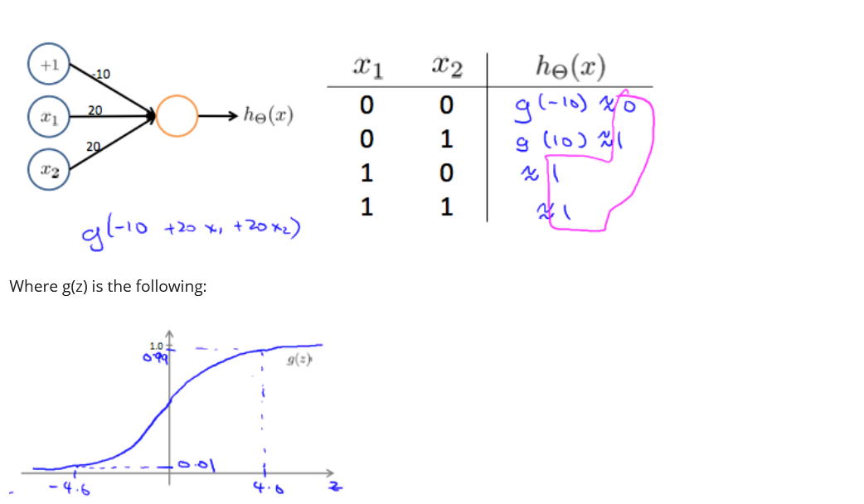

## **Examples and Intuitions-2**

Lets see how a neural network can compute complex non-linear hypothesis??

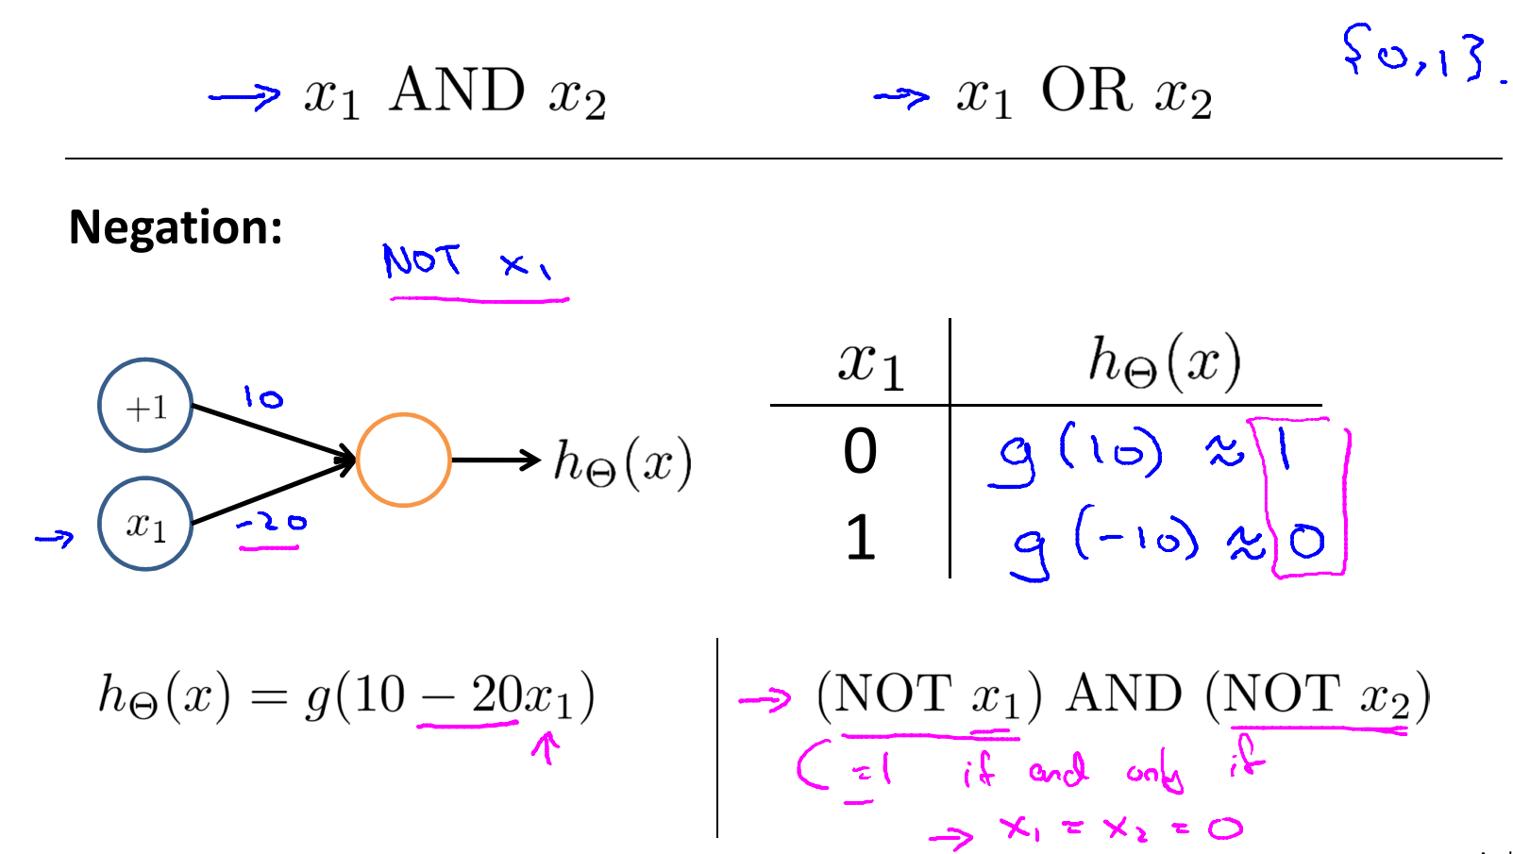

### **Quiz**

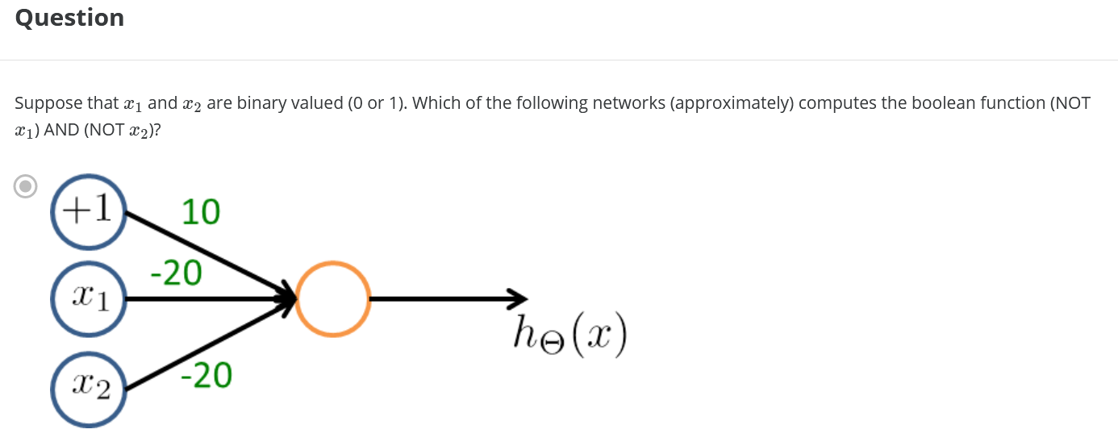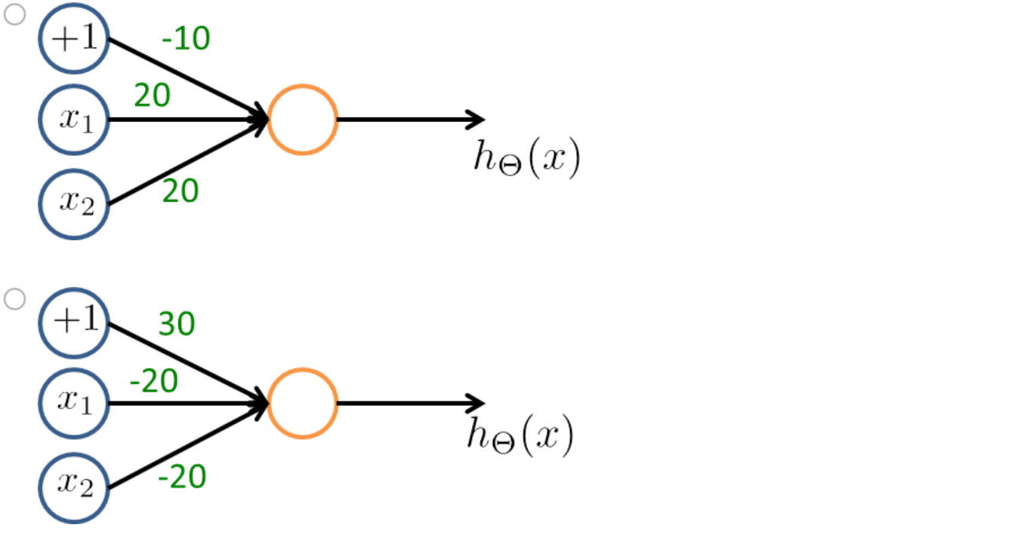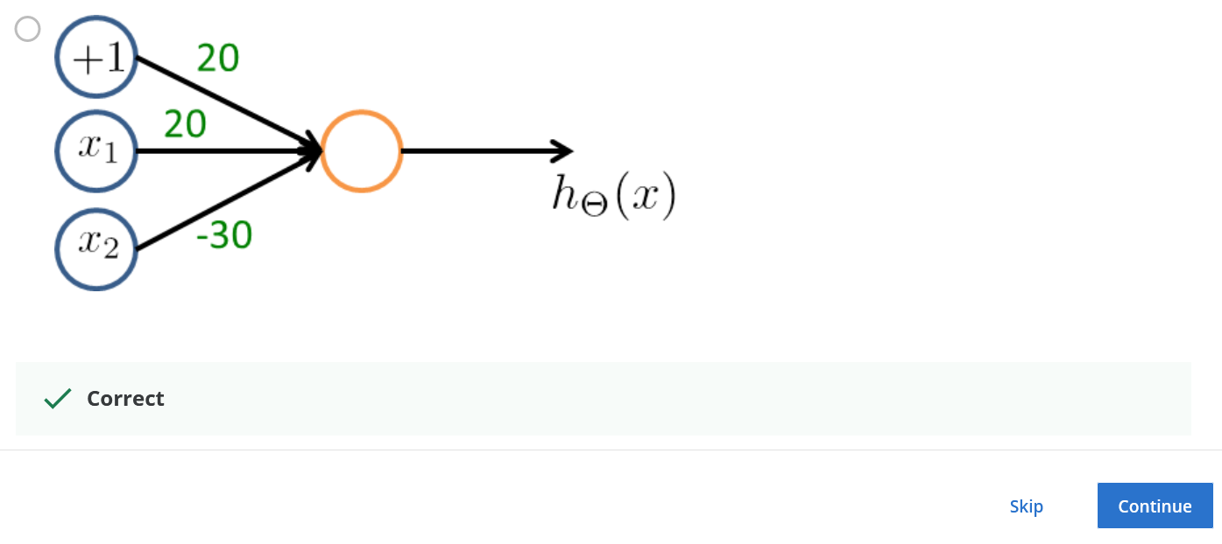

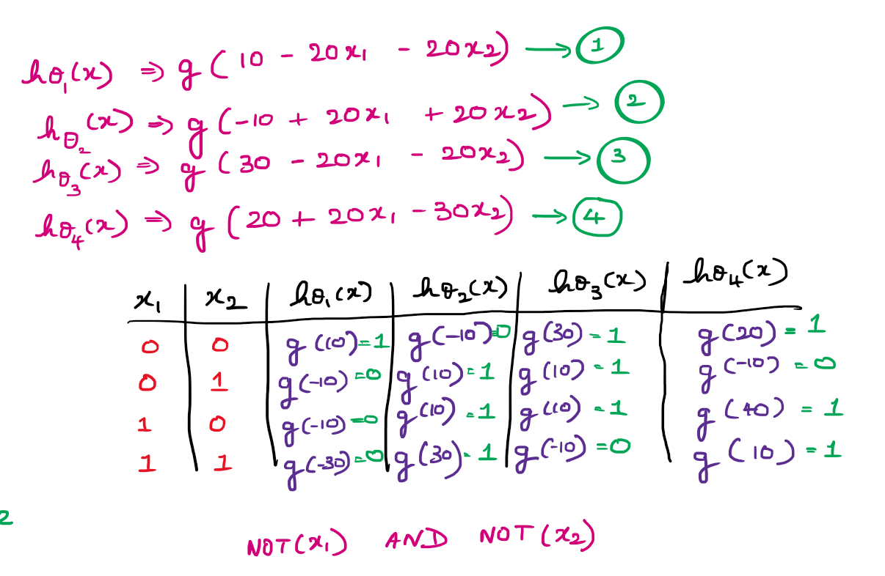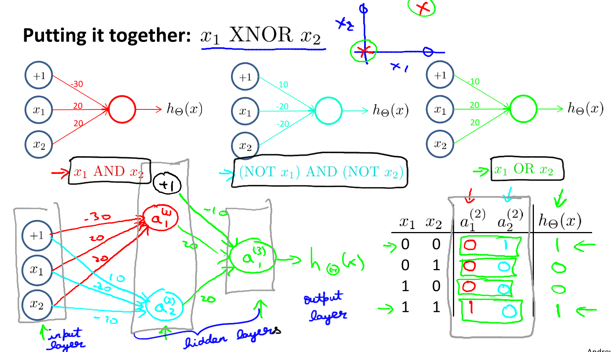This is a Non-Linear Decision Boundary that computes the XNOR function.

Red color 🡪 x1 AND x2   
Blue color 🡪 (Not x1) AND (Not x2)  
Green color 🡪 x1 OR x2

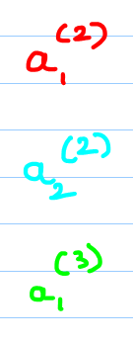

### **Reading Examples and Intuition-2**

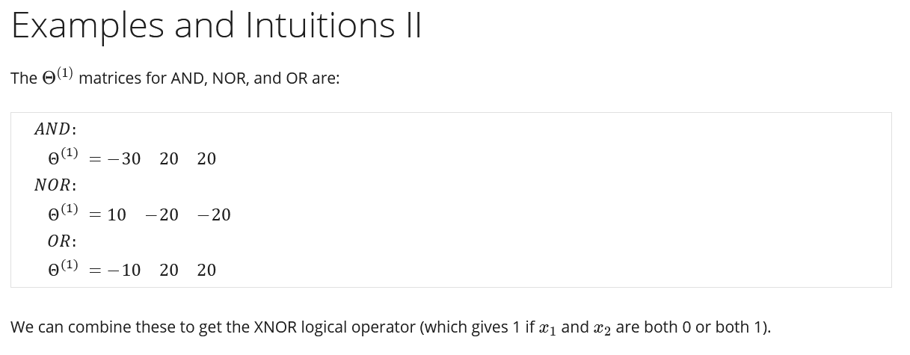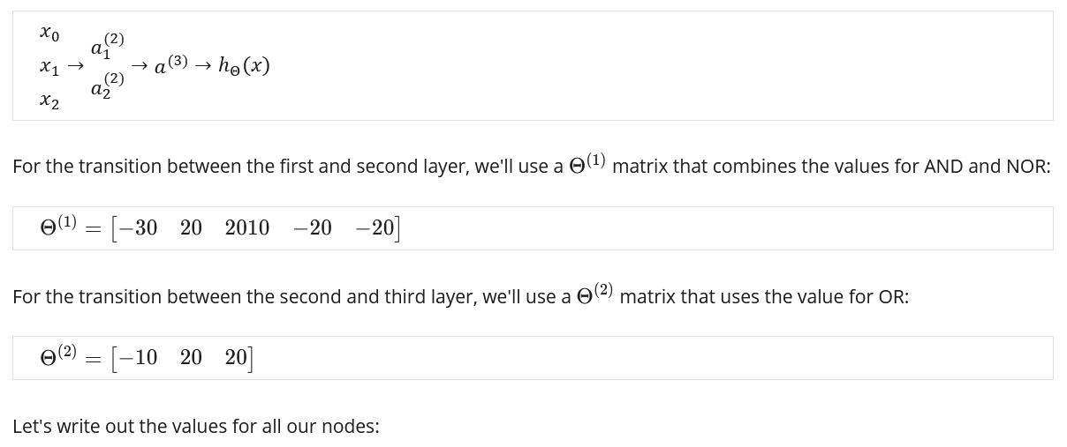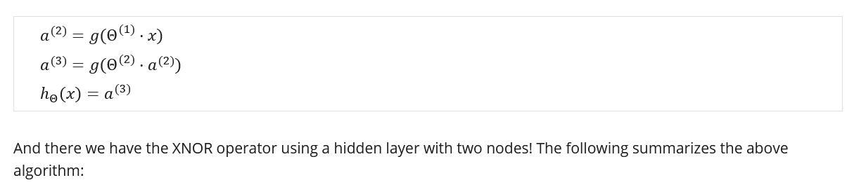

## **Multi-class classification**

With Neural Networks, how to do multi-class classification ???

We are trying to re-cognize 4 categories of the objects, given an image we want to decide if it is a pedestrian, a car, a motor-cycle or a truck.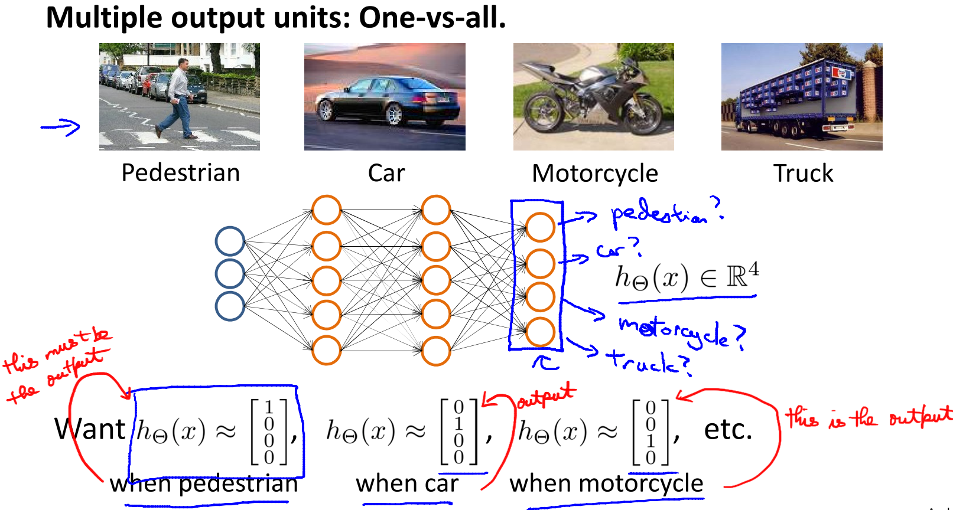So this is just like the "one versus all" method that we talked about when we were describing logistic regression, and here we have essentially four logistic regression classifiers, each of which is trying to recognize one of the four classes that we want to distinguish amongst. 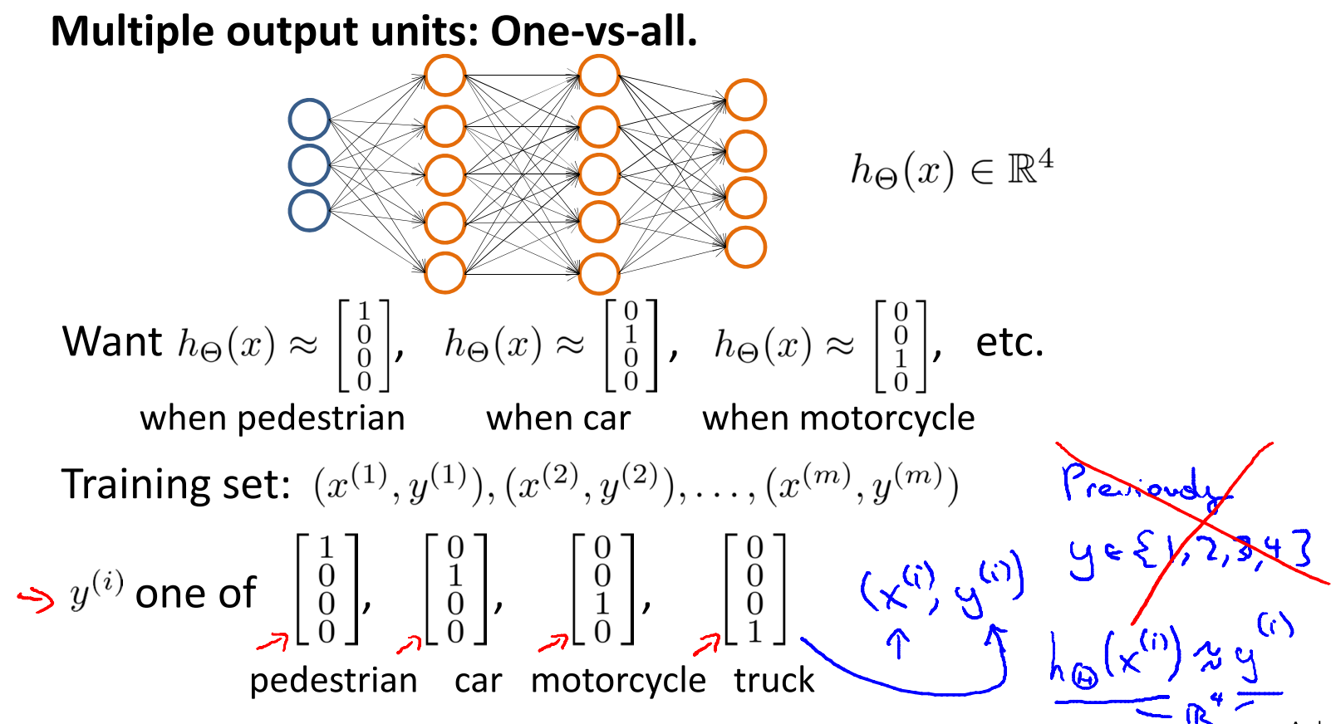

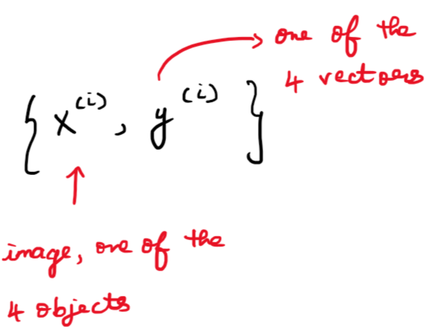

### **Quiz**

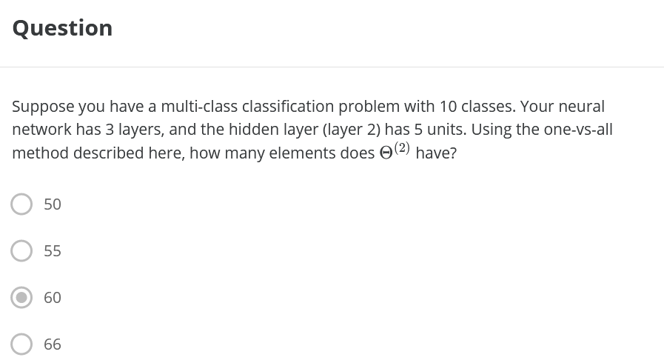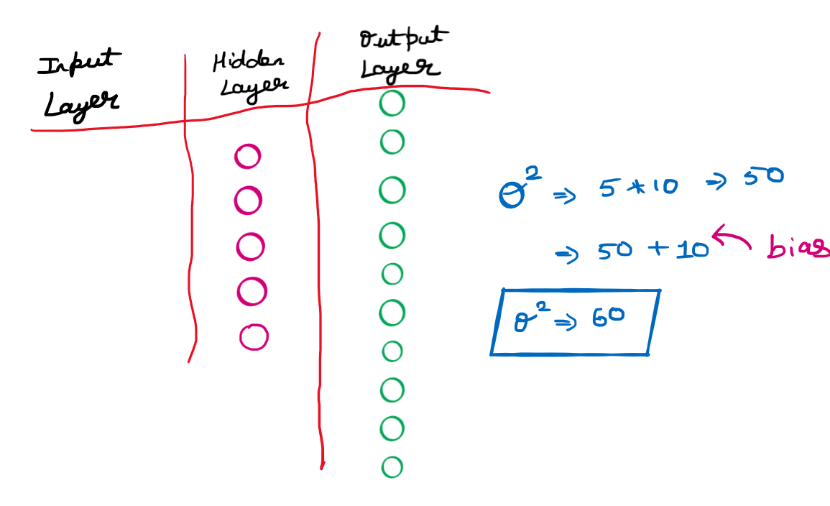

# **Review**

### **Quiz**

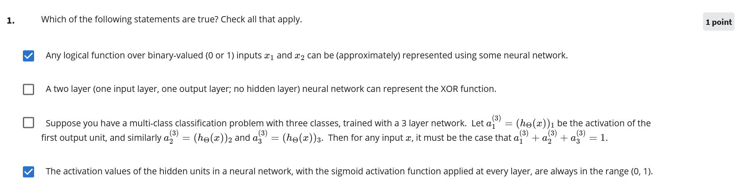

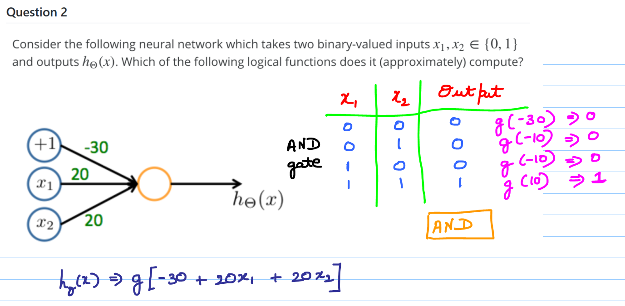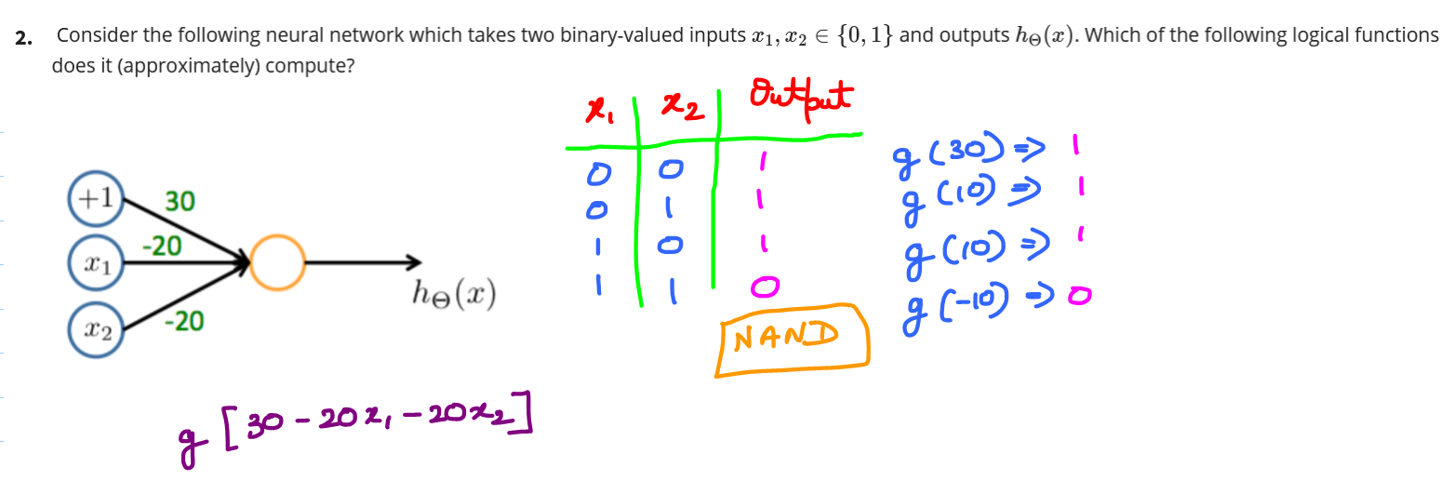

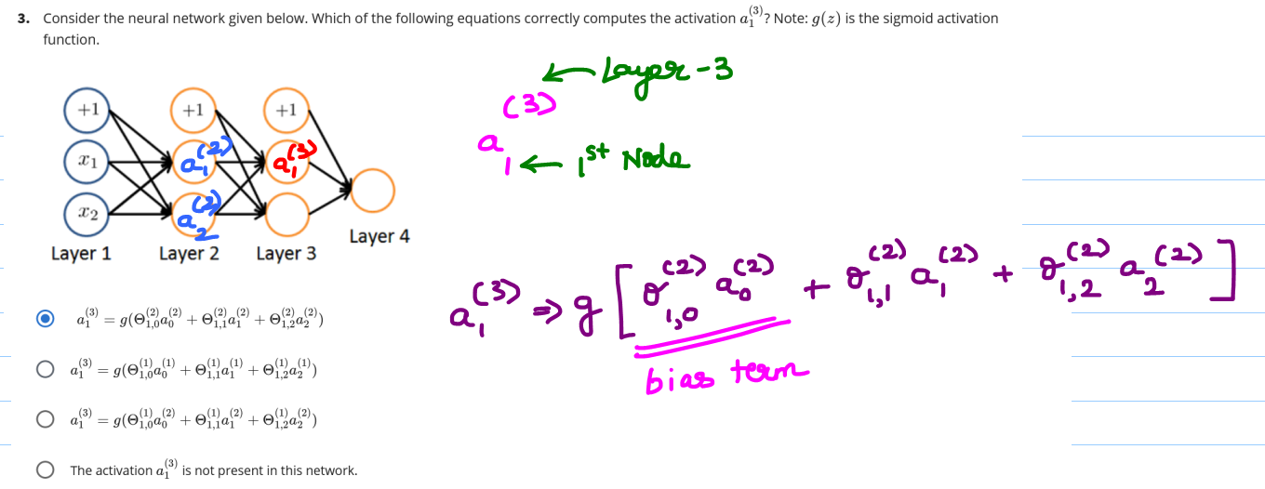

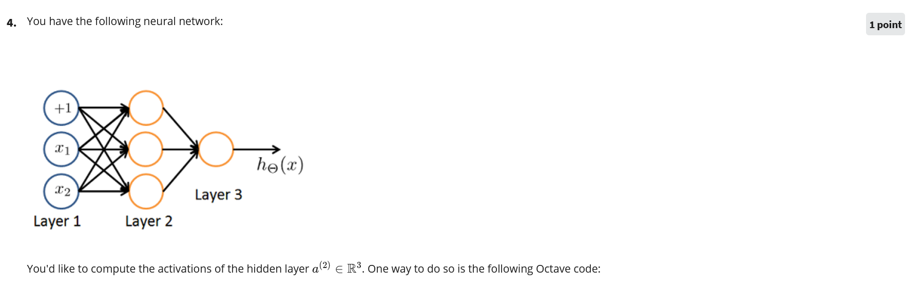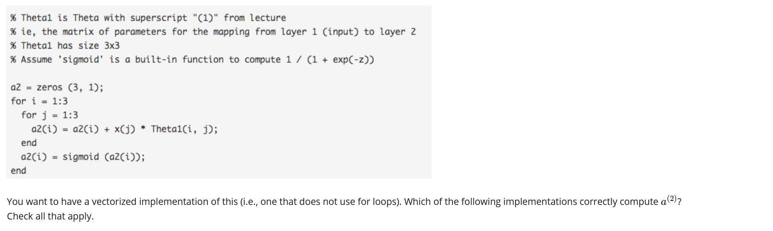  
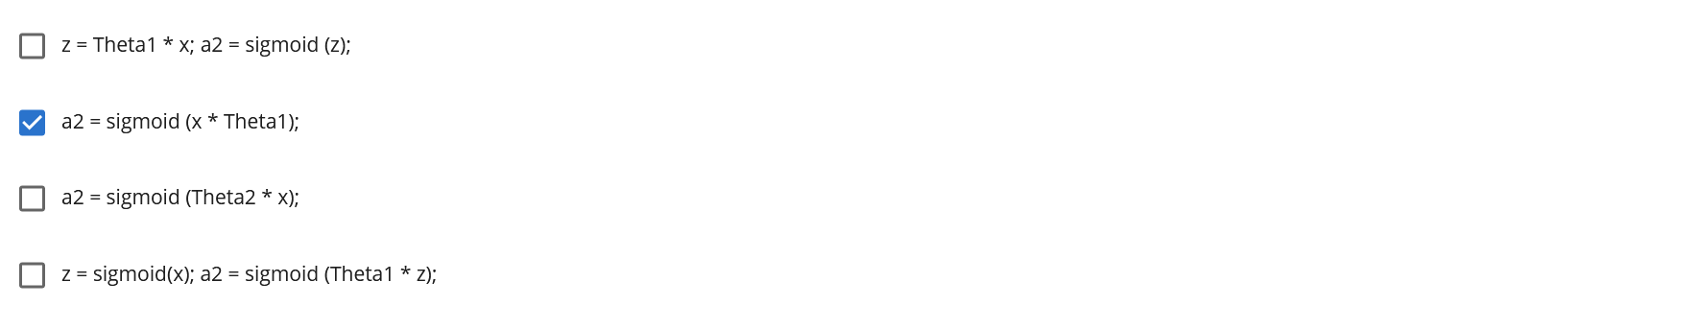

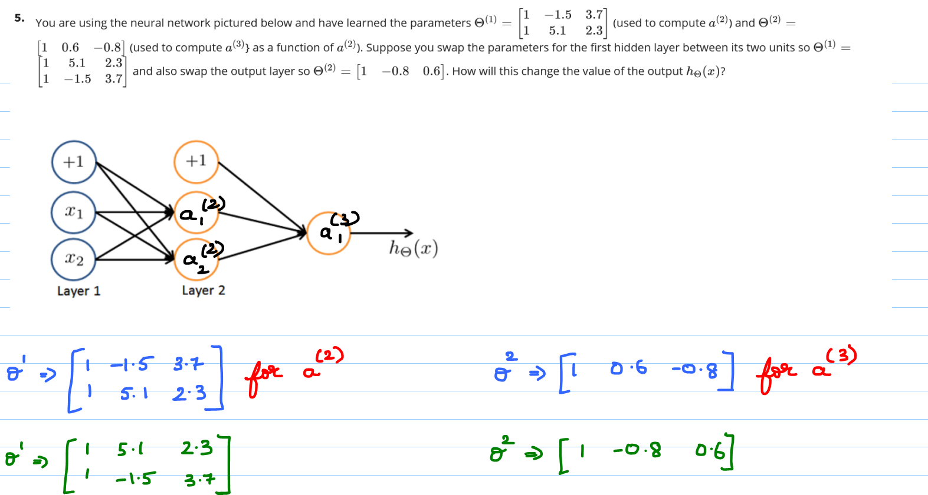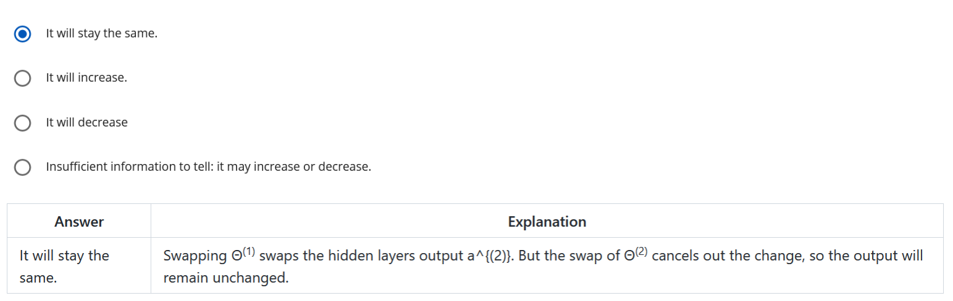

# **Google Developers**

Some of the commonly used Activation functions. 